CATHERINE SMEREENA DOMMATY

catherinesmereena.dommaty@gmail.com

ALY 6030 – DATA WAREHOUSING AND SQL. CRN: 70674

Week 2 Assignment_2.

**Introduction**

This assignment centres on creating a relational database for a cars dataset, which will help in organising, storing, and managing information about different car models and their specifications. The goal is to build a structured database that follows normalisation principles to ensure data integrity, reduce redundancy, and enable efficient data retrieval. By the end of this project, I aim to produce a comprehensive database design, including an entity-relationship diagram (ERD) that visually represents the relationships between various entities.

**Goals and Expectations**

The key objectives of this assignment are:

1. Database Design: Develop a well-organised relational database that categorises the cars dataset into distinct, logically connected tables.

2. Normalisation: Implement normalisation techniques (1NF, 2NF, and 3NF) to minimise data redundancy and maintain data integrity.

3. ERD Creation: Create an entity-relationship diagram that visually depicts the database structure, clearly showing the relationships among different entities.

4. Query Capabilities: Ensure the database design allows for efficient querying to facilitate data retrieval and analysis.

I expect to design a database that is functional and scalable, enabling future adjustments and expansions as necessary.

**Selected Dataset**

The dataset I have chosen contains detailed information about various car models, including attributes such as car name, fuel efficiency (MPG), engine horsepower, weight, acceleration, model year, and country of origin. This dataset is essential for analysing car performance and specifications, providing valuable insights into trends within the automotive industry.

**Tools and Languages**

For this project, I will use the following tools and technologies:

MySQL: This will be the main relational database management system for designing the database schema, creating tables, and performing data manipulation tasks.

MySQL Workbench: This graphical interface will assist in database design and management, allowing for easy visualisation of the schema and the generation of the ERD.

SQL: The Structured Query Language (SQL) will be used for creating, modifying, and querying the database, enabling efficient data handling and retrieval.

By utilising these tools and technologies, I aim to build a robust database system that effectively meets the objectives of this assignment and offers valuable insights into the cars dataset.

**Data Normalisation for Cars Dataset:**

**1. First Normal Form (1NF): Ensuring Atomic Values**

To ensure that each attribute contains atomic (indivisible) values, eliminating repeating groups and storing one piece of information per column.

Problem: In this case, the data already appears to be in 1NF since no column contains multiple values or lists. Each car attribute—like name, MPG, cylinders, horsepower, weight, etc.—holds a single piece of data. However, to demonstrate the process, we'll restructure the data into a clean format using the Cars_1NF table.

Step:1 Create Table in 1NF:

I wrote a SQL command to create a table named Cars_1NF, where each car's attribute is stored in a single column. All the car details from the carsdetail table are inserted into this new table.

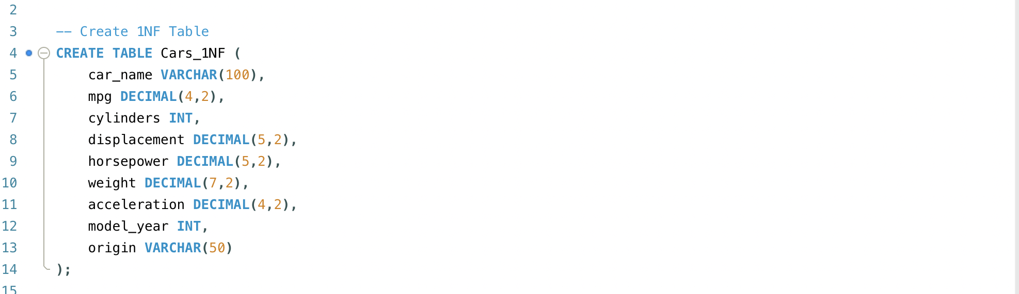

Insert Data into 1NF Table: The data is then inserted by selecting all columns from the carsdetail table. Each row now holds atomic values for all car attributes.

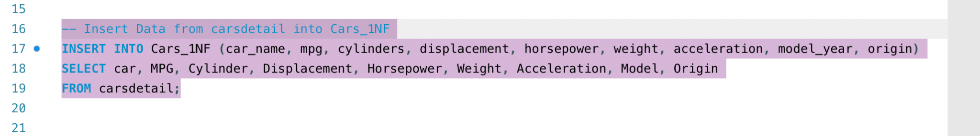

Outcome: The Cars_1NF table ensures that each column contains atomic values, meaning that no attribute has multiple or nested values.

**Then used a select statement**

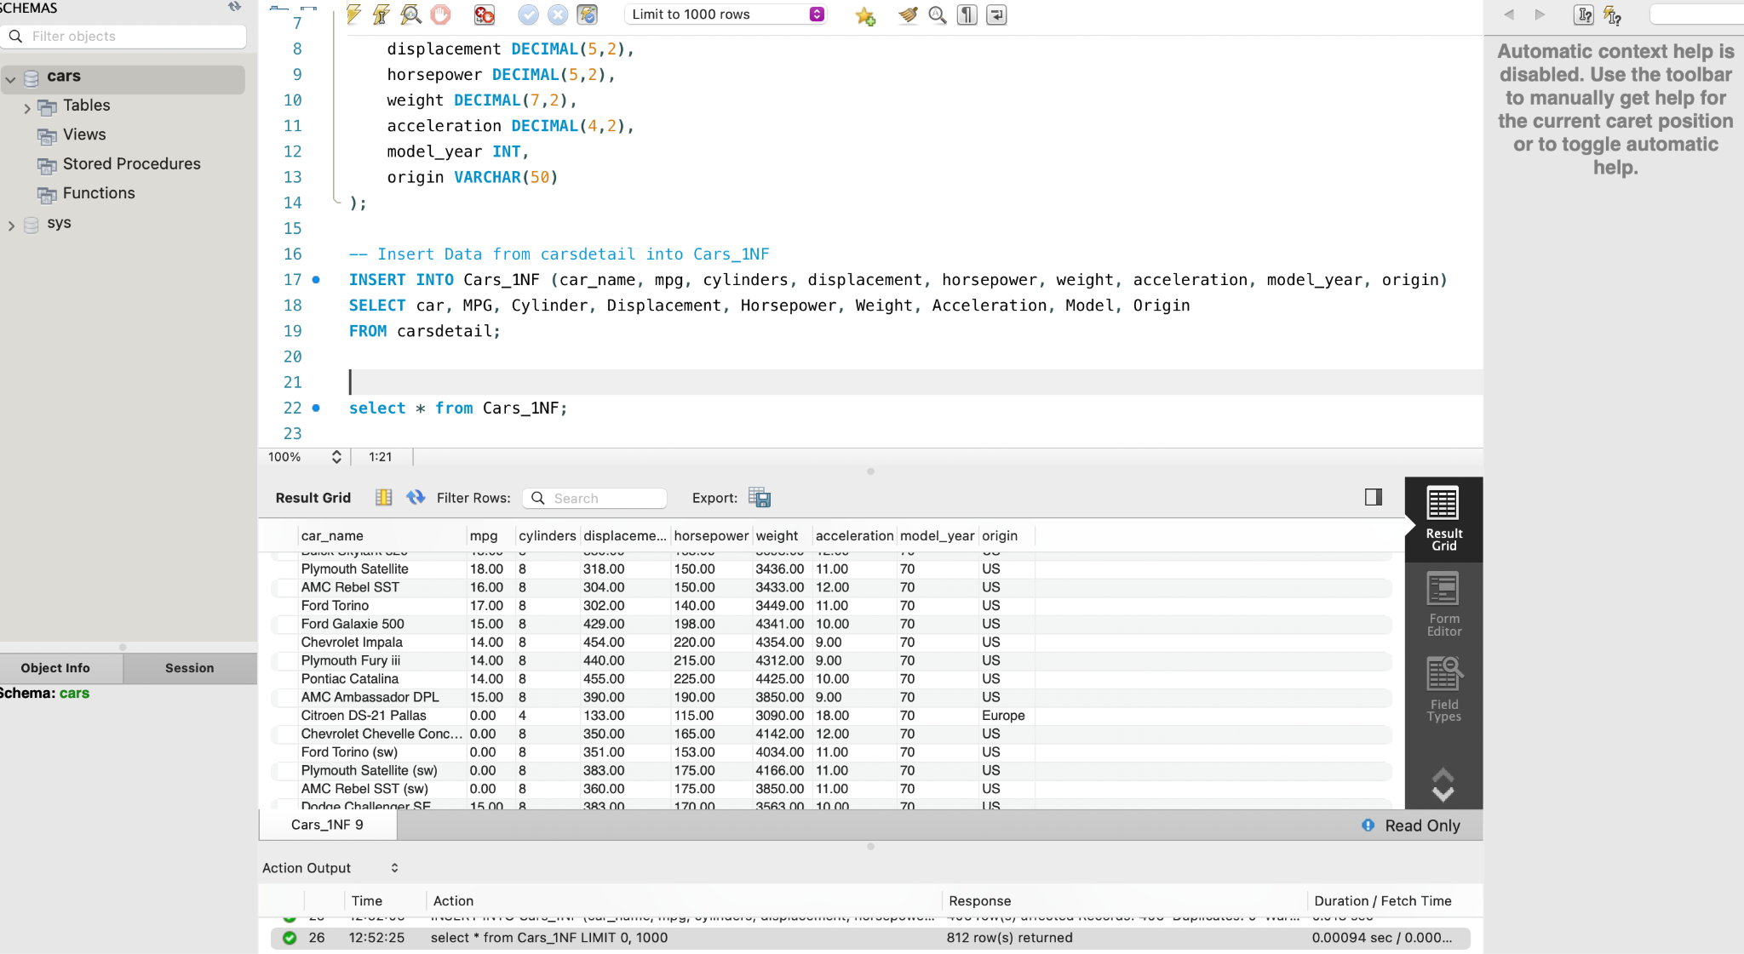

**2. Second Normal Form (2NF): Removing Partial Dependencies.**

To ensure that the table is in 2NF, which requires that it first satisfies 1NF and that all non-key attributes are fully functionally dependent on the primary key. This step removes any partial dependency that might exist if a composite primary key is used.

Problem: In our Cars_1NF table, attributes like model_year and origin are not fully dependent on the other attributes but only on certain parts, leading to partial dependencies. We can separate these out into new tables and link them using foreign keys.

Steps:2Create Cars_2NF Table:

I created a table Cars_2NF with the car's unique identifier (car_id) as the primary key and left out other attributes related to performance and specifications, except model_year and origin. The latter two were moved to separate tables.

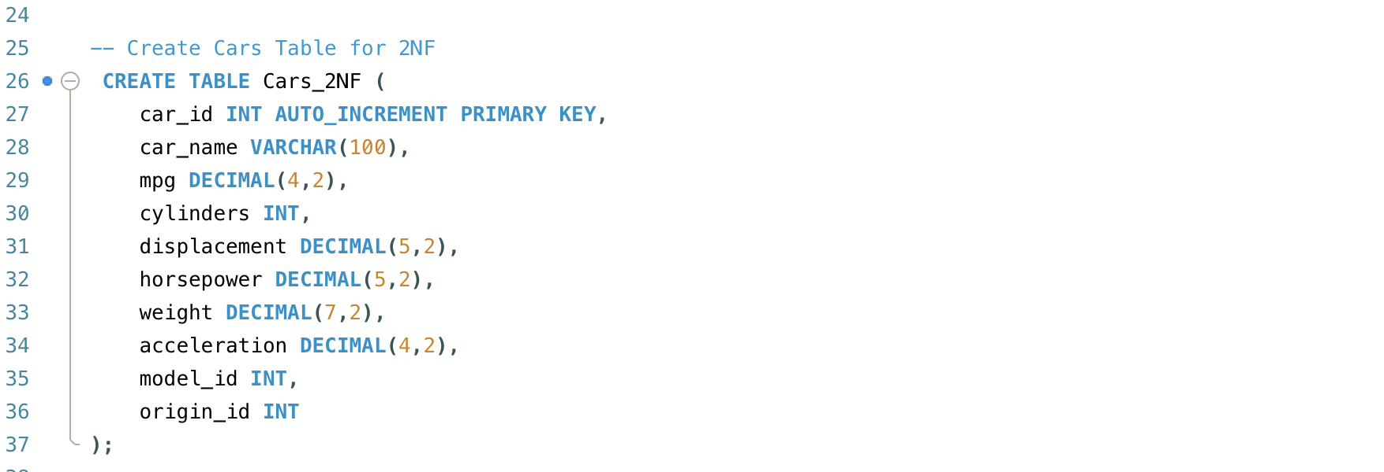

Create Model and Origin Tables: I created separate tables for model_year and origin, which will store the unique values for these attributes, eliminating redundancy and ensuring full functional dependency.

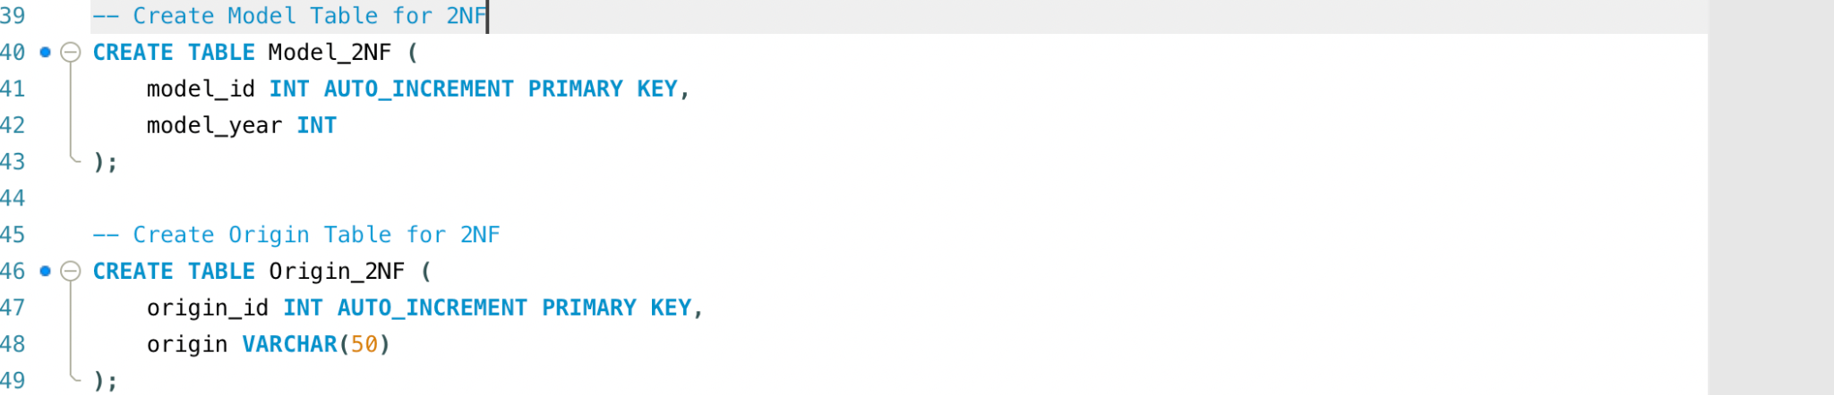

Insert Unique Values: I then populated these tables with unique model years and origins from the carsdetail table, ensuring that no redundant data is stored.

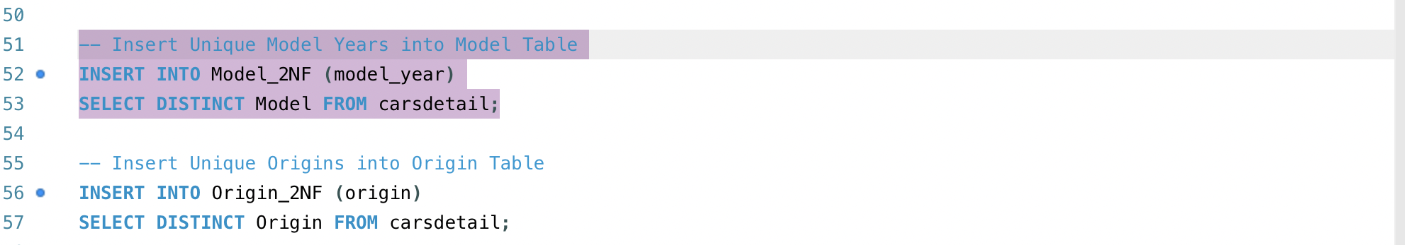

Link Cars to Models and Origins: Finally, I inserted data into the Cars_2NF table, linking it to the appropriate model_id and origin_id by referencing the Model_2NF and Origin_2NF tables.

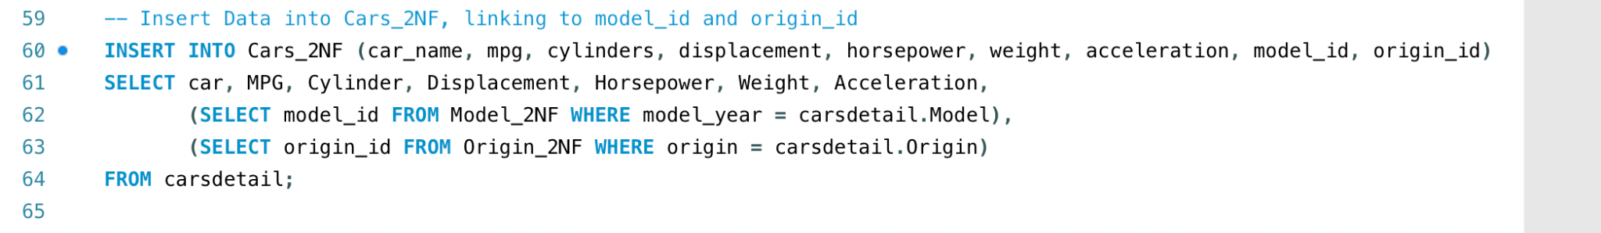

Select statement.

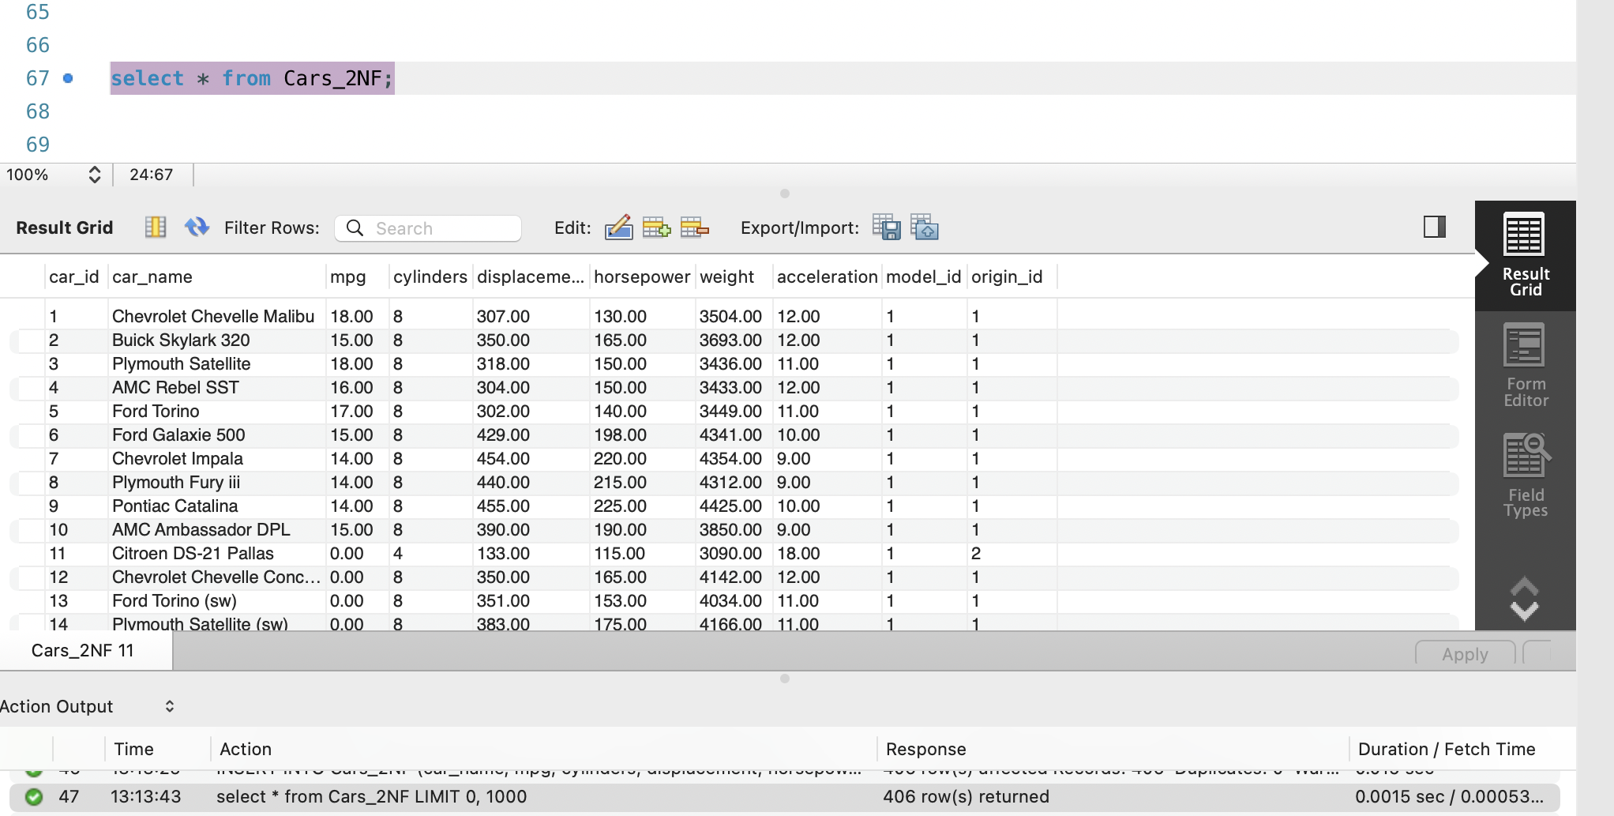

Outcome: The Cars_2NF table eliminates partial dependencies by moving model_year and origin into separate tables, ensuring that all non-key attributes are fully dependent on the primary key (car_id).

**3. Third Normal Form (3NF): Removing Transitive Dependencies.**

To ensure that the table is in 3NF, which requires that it first satisfies 2NF and that all non-key attributes are non-transitively dependent on the primary key, meaning there should be no indirect dependencies.

In Cars_2NF, some attributes like cylinders, displacement, and horsepower could be grouped together as they all relate to the car’s specifications. Additionally, attributes like mpg and acceleration describe the car’s performance. To eliminate transitive dependencies, we can split the data into separate tables.

Steps:3 Create Cars_3NF Table:

First, I created a new Cars_3NF table, which includes the car_id, model_id, and origin_id columns. This table stores general car information without repeating the specification or performance details.

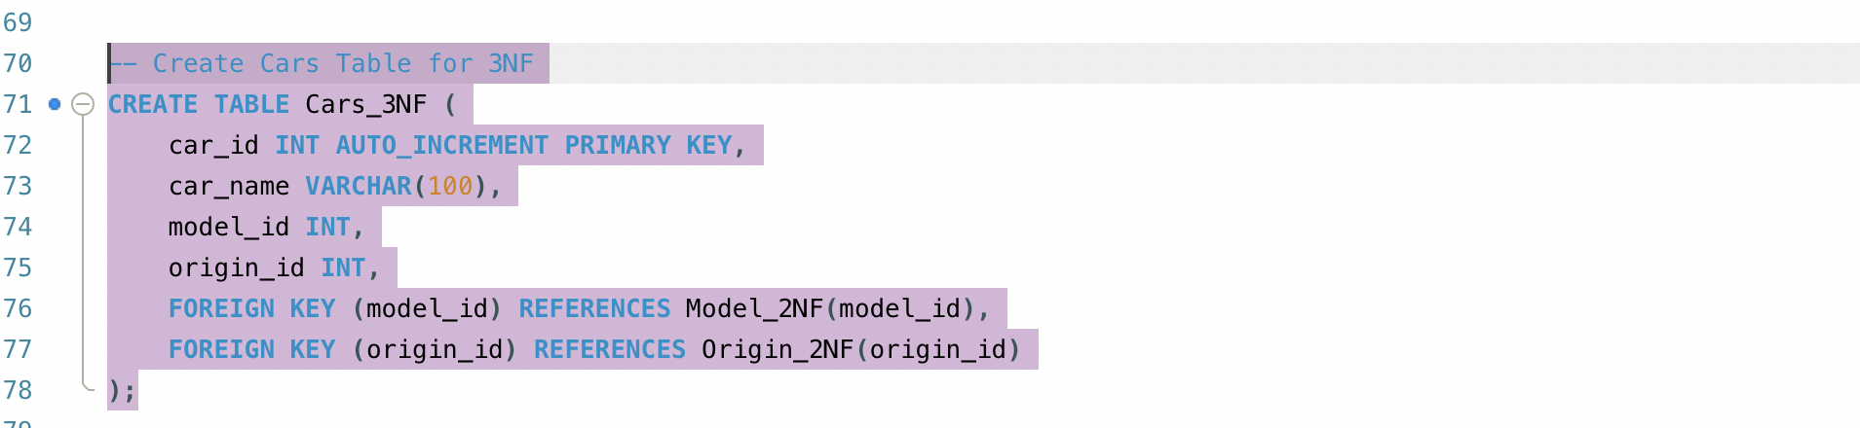

Create Specifications_3NF and Performance_3NF Tables: I then split the specification and performance data into their respective tables. This ensures that these attributes are only related to the car_id and eliminates transitive dependencies.

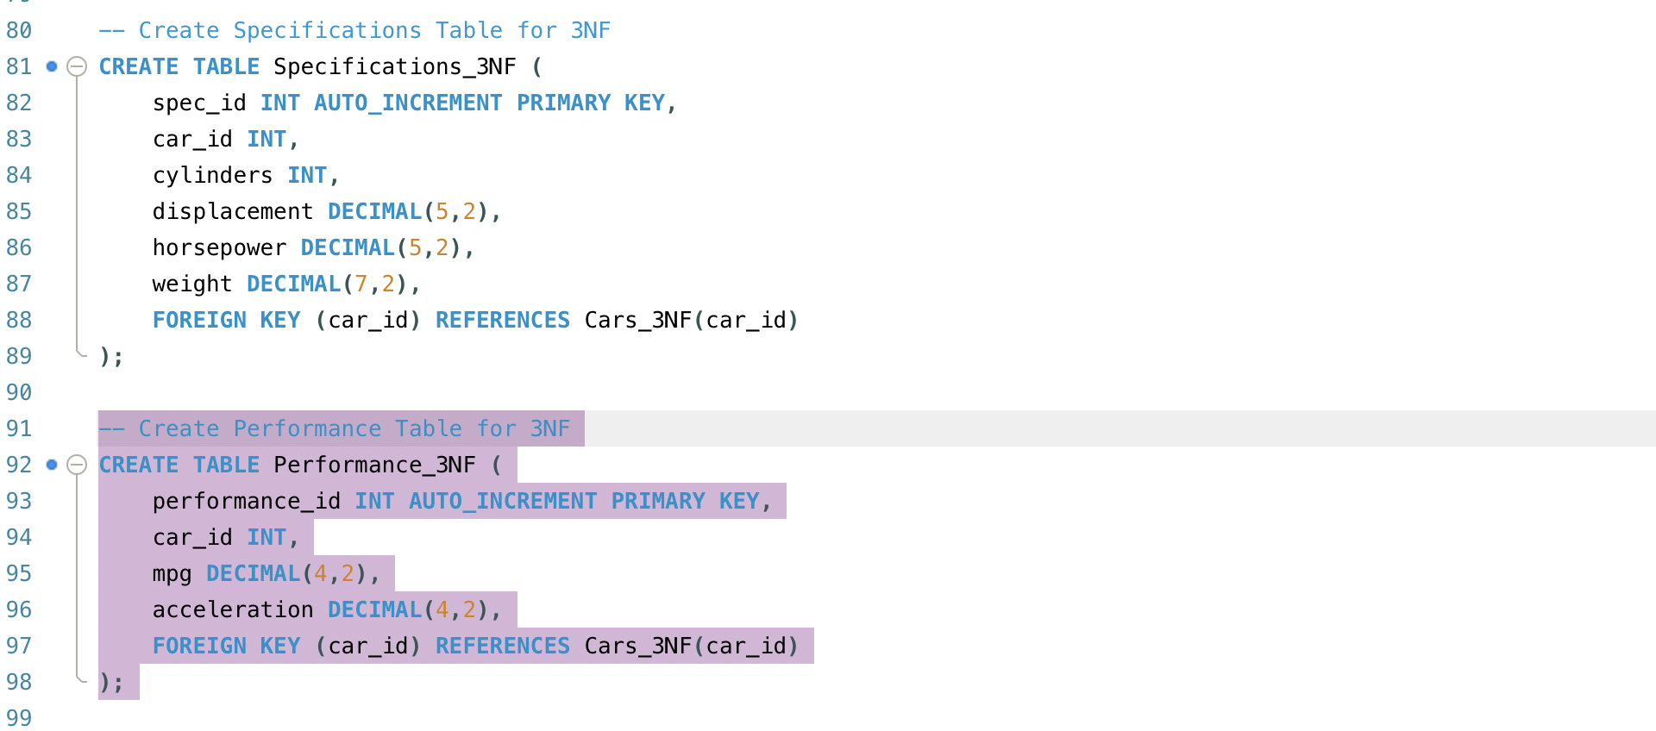

Insert Data into 3NF Tables: Finally, I inserted the data into the Cars_3NF, Specifications_3NF, and Performance_3NF tables, ensuring that each table is free from transitive dependencies.

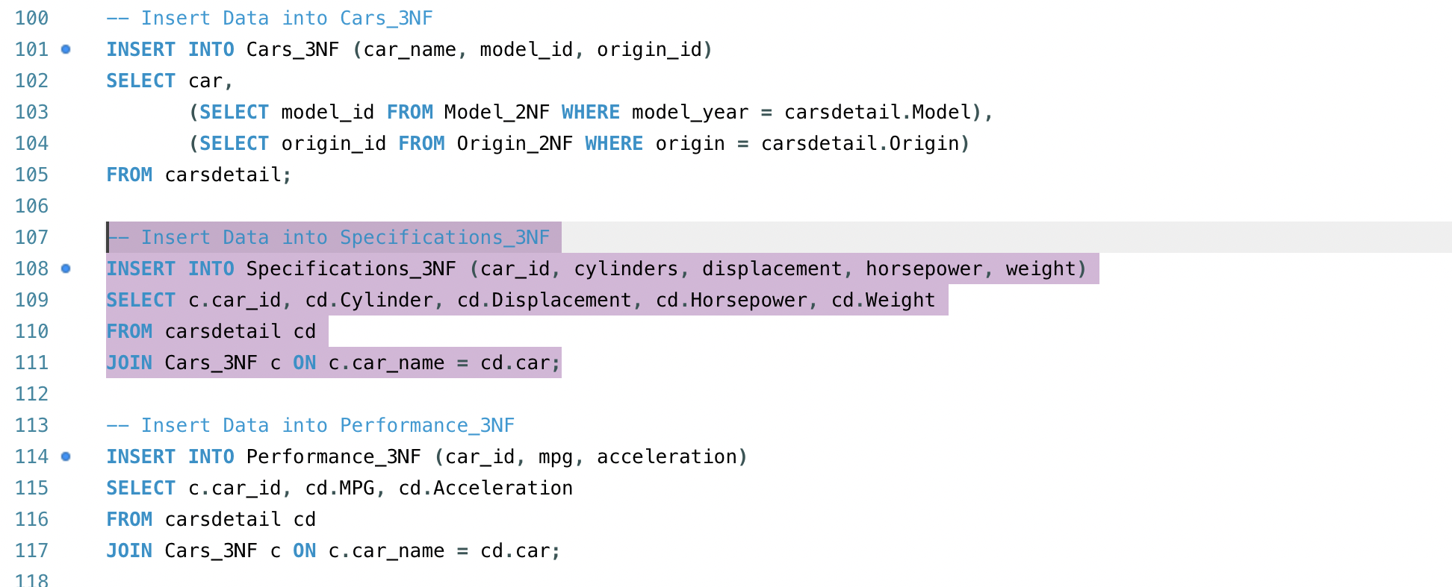

Outcome: The final Cars_3NF structure ensures that there are no transitive dependencies, with the Specifications_3NF and Performance_3NF tables storing related attributes, all linked to the car_id.

This step-by-step normalisation process—starting from 1NF through 3NF—ensures that the carsdetail dataset is free from redundancy, partial, and transitive dependencies, making the data clean, organised, and optimised for querying.

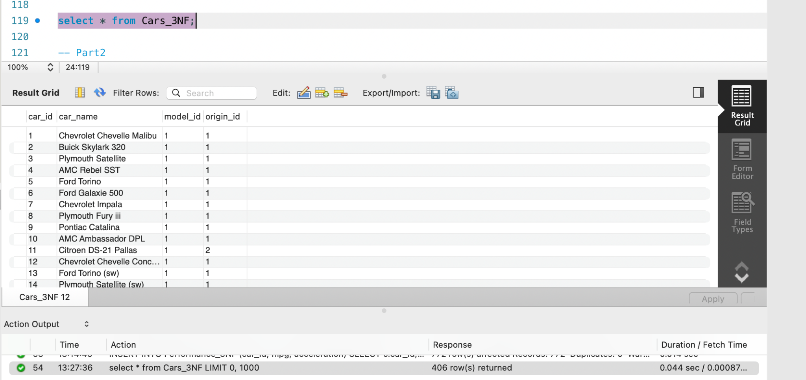

Decision on Database Design for Cars Dataset:

In designing my database for the cars dataset, I chose to create three separate tables: `Cars`, `Specifications`, and `Performance`, in addition to two auxiliary tables for `Model` and `Origin`. The decision was made based on the principles of functional dependency and normalisation. Here’s my reasoning behind this design choice:

**Functional Dependency**

I established functional dependency in the database by ensuring that each attribute in my tables depends directly on the primary key. In the `Cars` table, `car_id` serves as the primary key and uniquely identifies each car.

Here’s how the functional dependencies work for each table:

**Cars Table:**

car_name: This attribute identifies the car model and is directly associated with its unique `car_id`. Each car has a unique name for its corresponding `car_id`, ensuring that this relationship holds.

model_id: This foreign key links the car to the `Model` table, representing the year of the car model, thus reinforcing its relationship with the car.

origin_id: This foreign key links the car to the `Origin` table, indicating the country of origin, ensuring that each car's origin is directly related to its `car_id`.

**Specifications Table:**

cylinders, displacement,horsepower, and weight: These attributes provide specific details about the car’s specifications and are directly linked to the `car_id`. Each specification is uniquely associated with a car, ensuring that they are only recorded once per car.

**Performance Table:**

mpg and acceleration: These performance-related attributes are also tied directly to the `car_id`. Each car's performance metrics are uniquely linked to it, avoiding redundancy.

**Model Table:**

model_year: This attribute is uniquely associated with `model_id`, ensuring that each model year corresponds to only one `model_id`.

**Origin Table:**

origin: This attribute is uniquely associated with `origin_id`, ensuring that each country of origin corresponds to only one `origin_id`.

**Normalisation:**

By structuring the database this way, I ensured that it adheres to the principles of normalisation:

**First Normal Form (1NF):** Each table contains only atomic values, meaning that no column holds multiple values. In the `Cars` table, each car has a unique `car_id`, and attributes like `car_name`, `model_id`, and `origin_id` are directly associated with it. Similarly, in the `Specifications` and `Performance` tables, each attribute holds a single value per row.

**Second Normal Form (2NF):** Since I separated `Specifications` and `Performance` into their own tables, I removed partial dependencies. Each table contains attributes that are fully dependent on the primary key. For example, the `Specifications` table lists car specifications uniquely identified by `car_id`, ensuring that any specification detail corresponds directly to its car.

**Third Normal Form (3NF):** There are no transitive dependencies in my design. The attributes in each table are solely dependent on the primary key without relying on other non-key attributes. For instance, the `model_year` and `origin` remain in their respective tables because they are direct attributes and not dependent on other attributes.

This structured approach to database design ensures that the cars dataset is organised efficiently, maintains data integrity, and minimises redundancy. The separation into distinct tables for cars, specifications, performance, models, and origins promotes clarity and facilitates easier maintenance and querying of the dataset.

**ERD:**

Steps to Create an ERD for the Cars Dataset

Step 1:

To begin the process of creating an ERD, I opened MySQL Workbench and navigated to the "Database" menu. From there, I selected the "Reverse Engineer" option. This feature allowed me to extract the schema from the existing cars database, enabling the visualisation of the database structure in the form of an entity-relationship diagram (ERD).

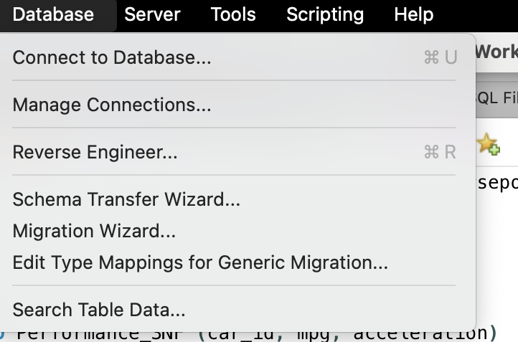

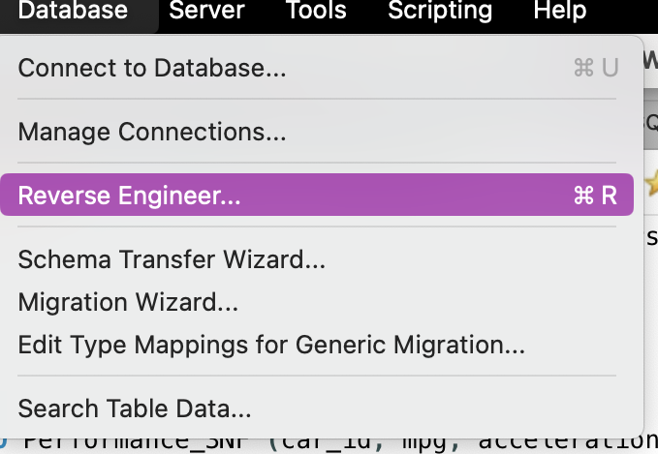

Step 2:

Next, I configured the default connection parameters for the database management system (DBMS). I selected the local MySQL instance on port 3306, using the standard TCP/IP method. For the hostname, I used "localhost" and logged in with the default "root" username. These configurations ensured I could proceed smoothly with the reverse engineering process.

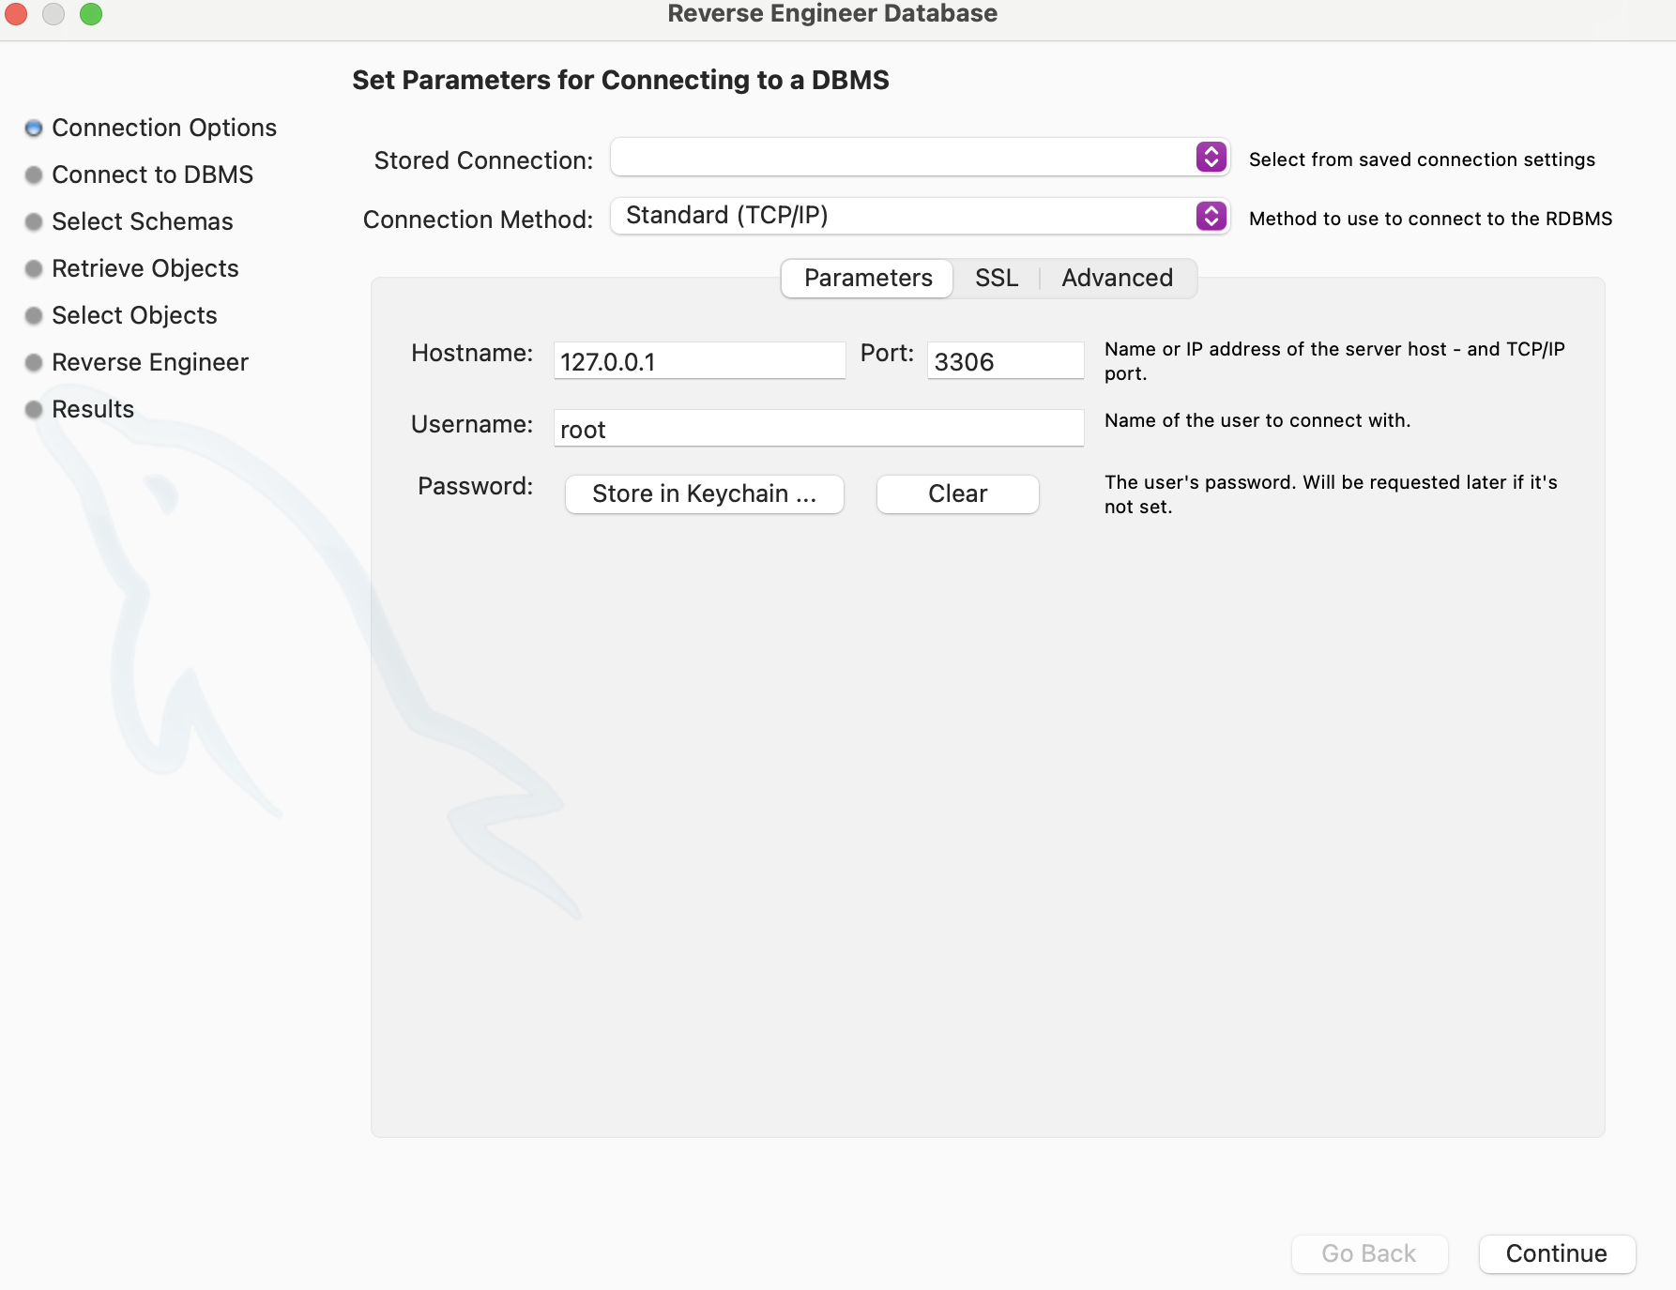

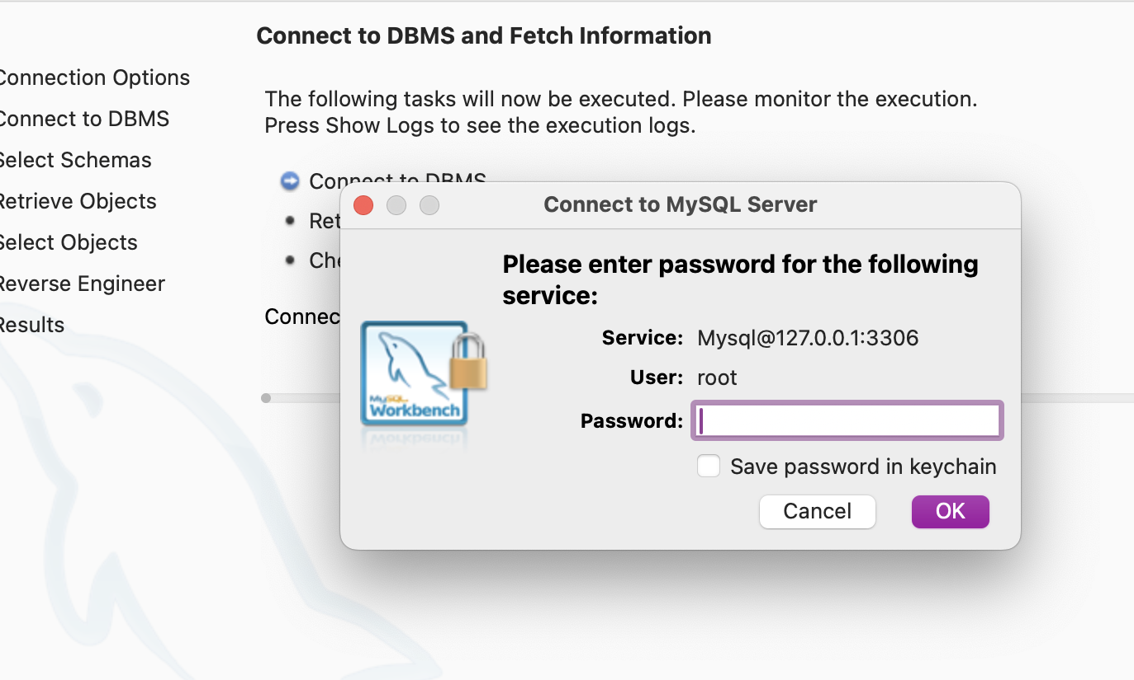

Step 3:

Once connected to the DBMS, the system successfully fetched the required information. The available schemas on the server were retrieved without any issues, confirming that the connection was stable and there were no configuration problems on the server.

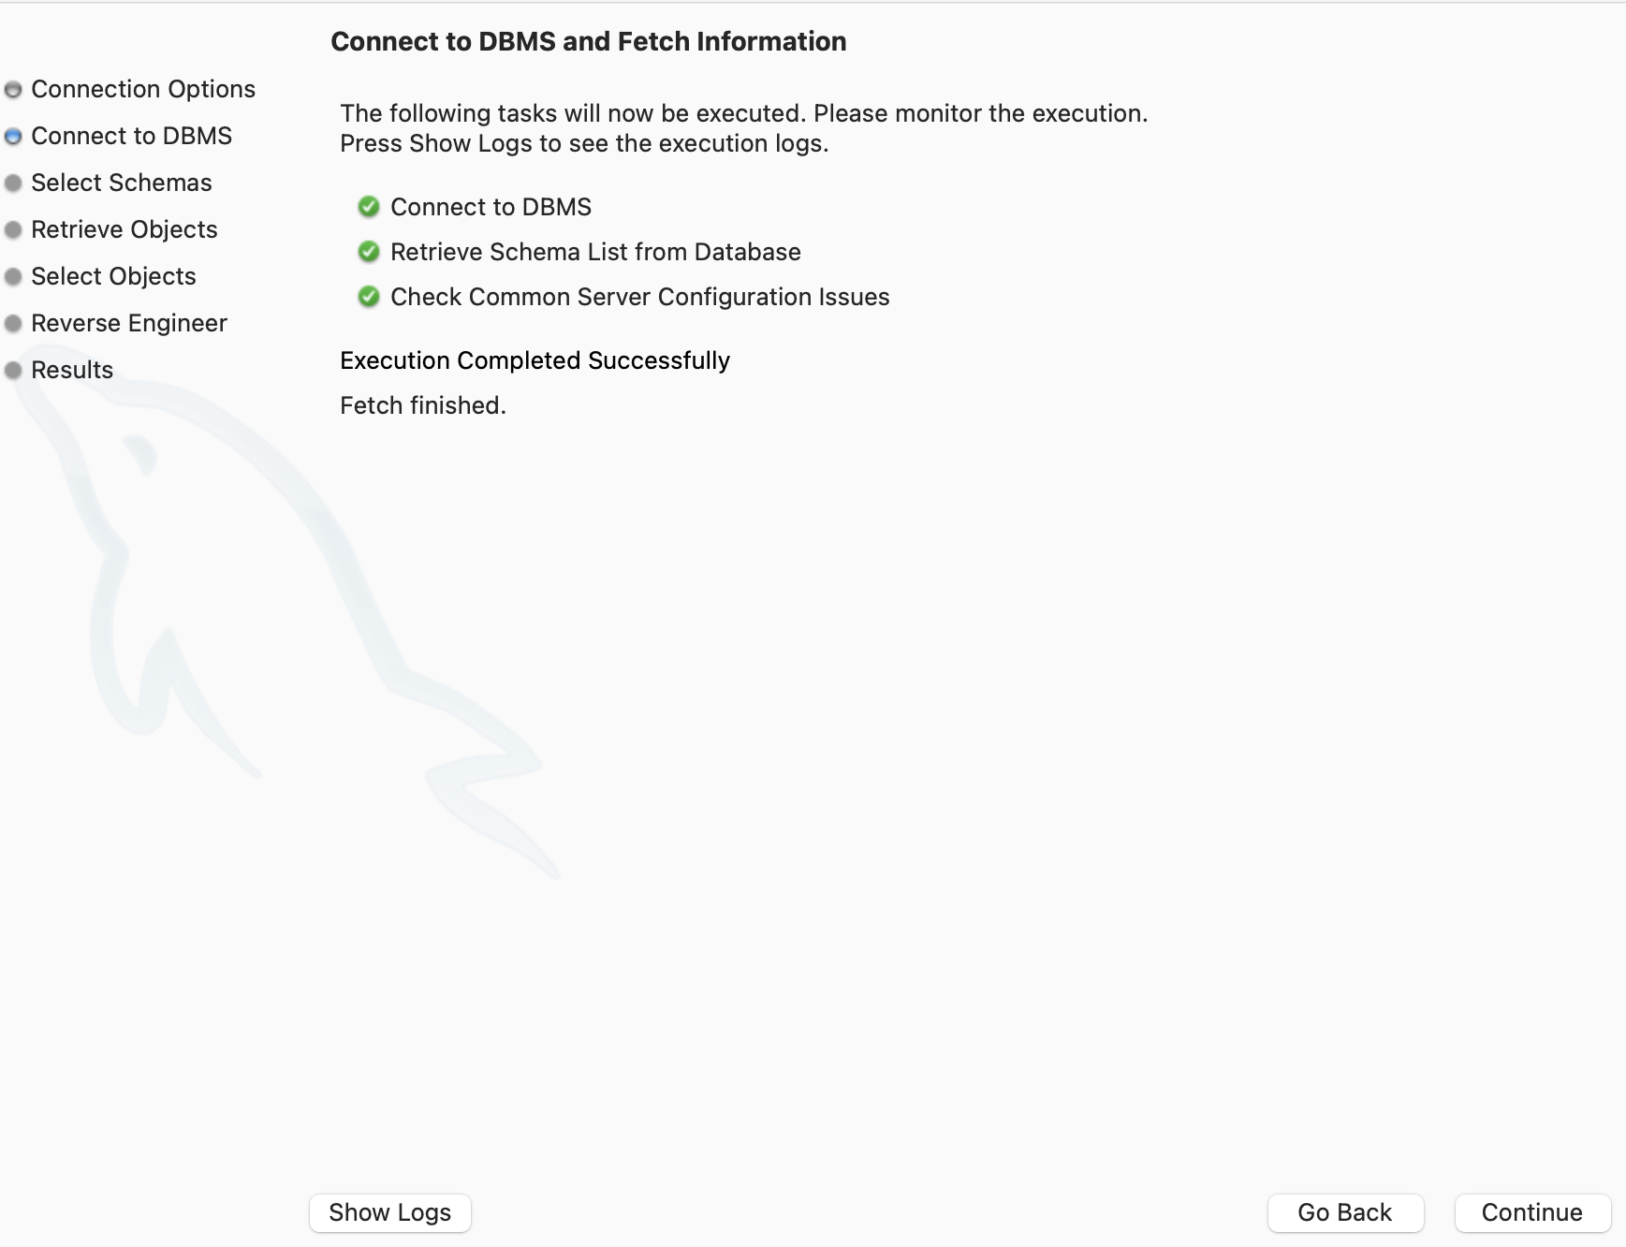

Step 4:

At this stage, I selected the specific schema I intended to reverse engineer—namely, the "cars" schema.

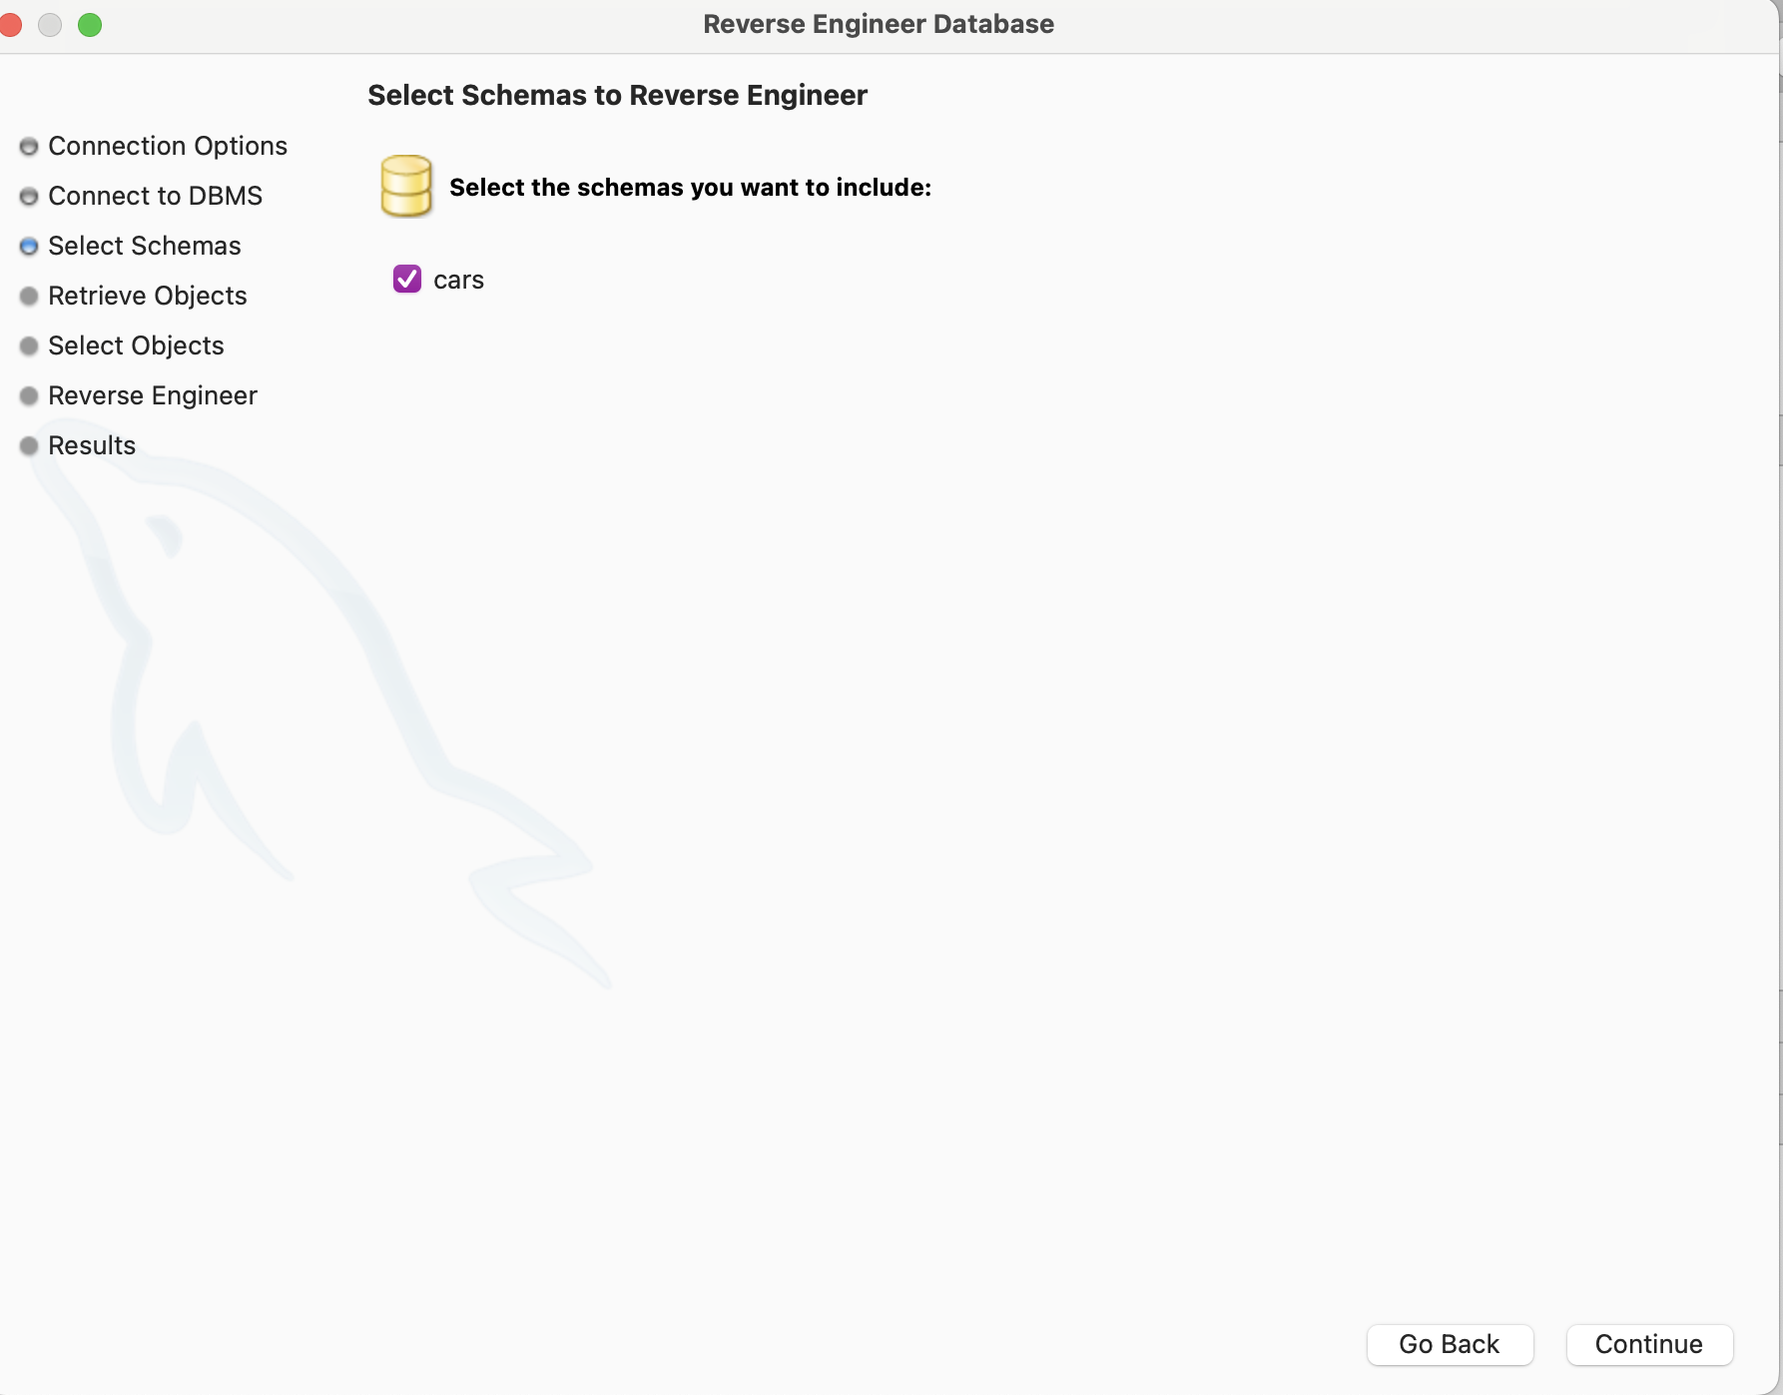

Step 5:

After confirming my schema selection, I proceeded to retrieve and reverse engineer the schema objects from the chosen "cars" schema. The operation was successful, with all the necessary schema components retrieved and prepared for visual representation.

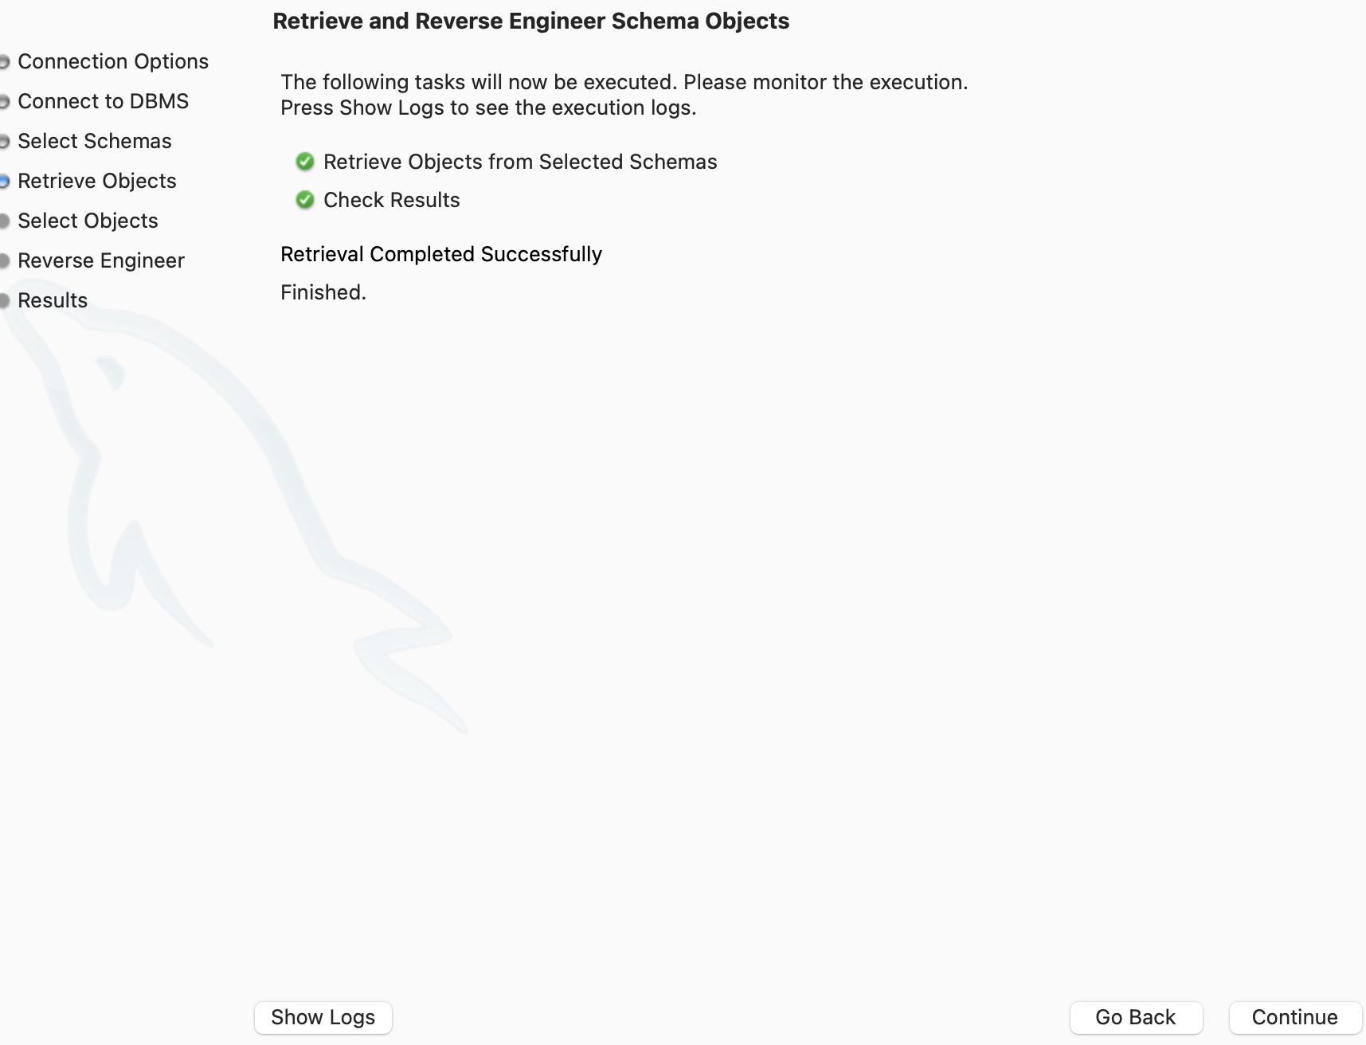

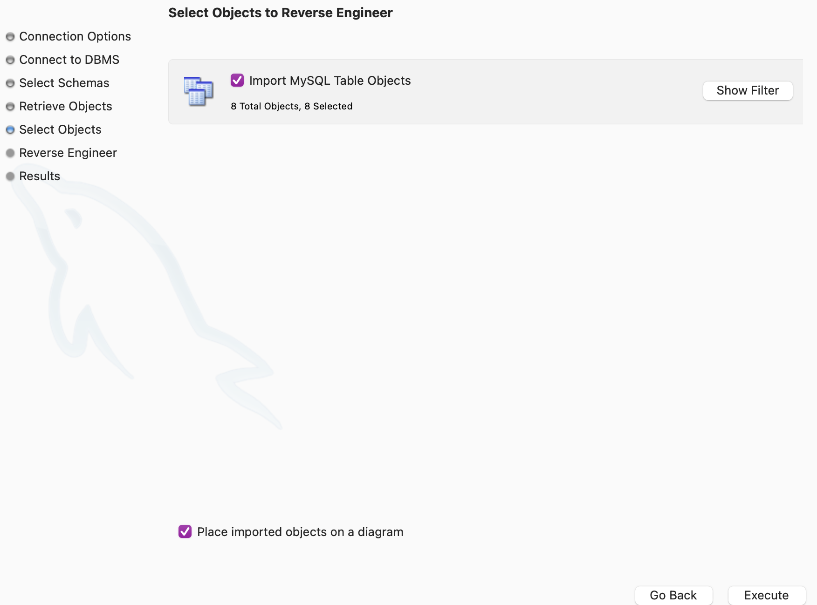

Step 6:

Following that, I carefully selected the specific objects to reverse engineer. These included the MySQL tables related to Cars, Specifications, Performance, Model, and Origin. I made sure to exclude any irrelevant tables or objects that were not related to the cars dataset. This helped to maintain the clarity and focus of the final ERD.

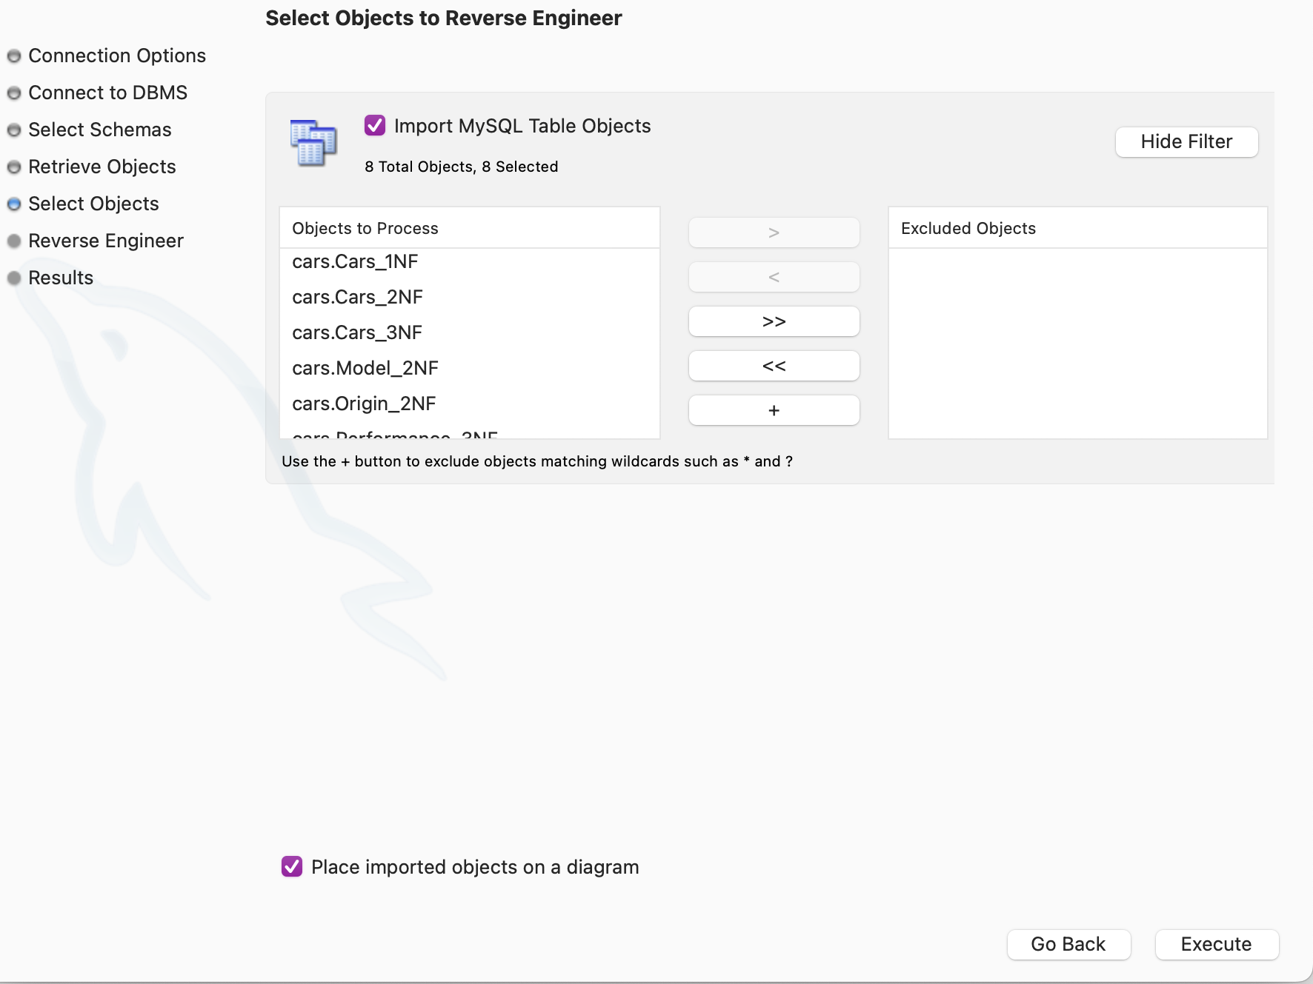

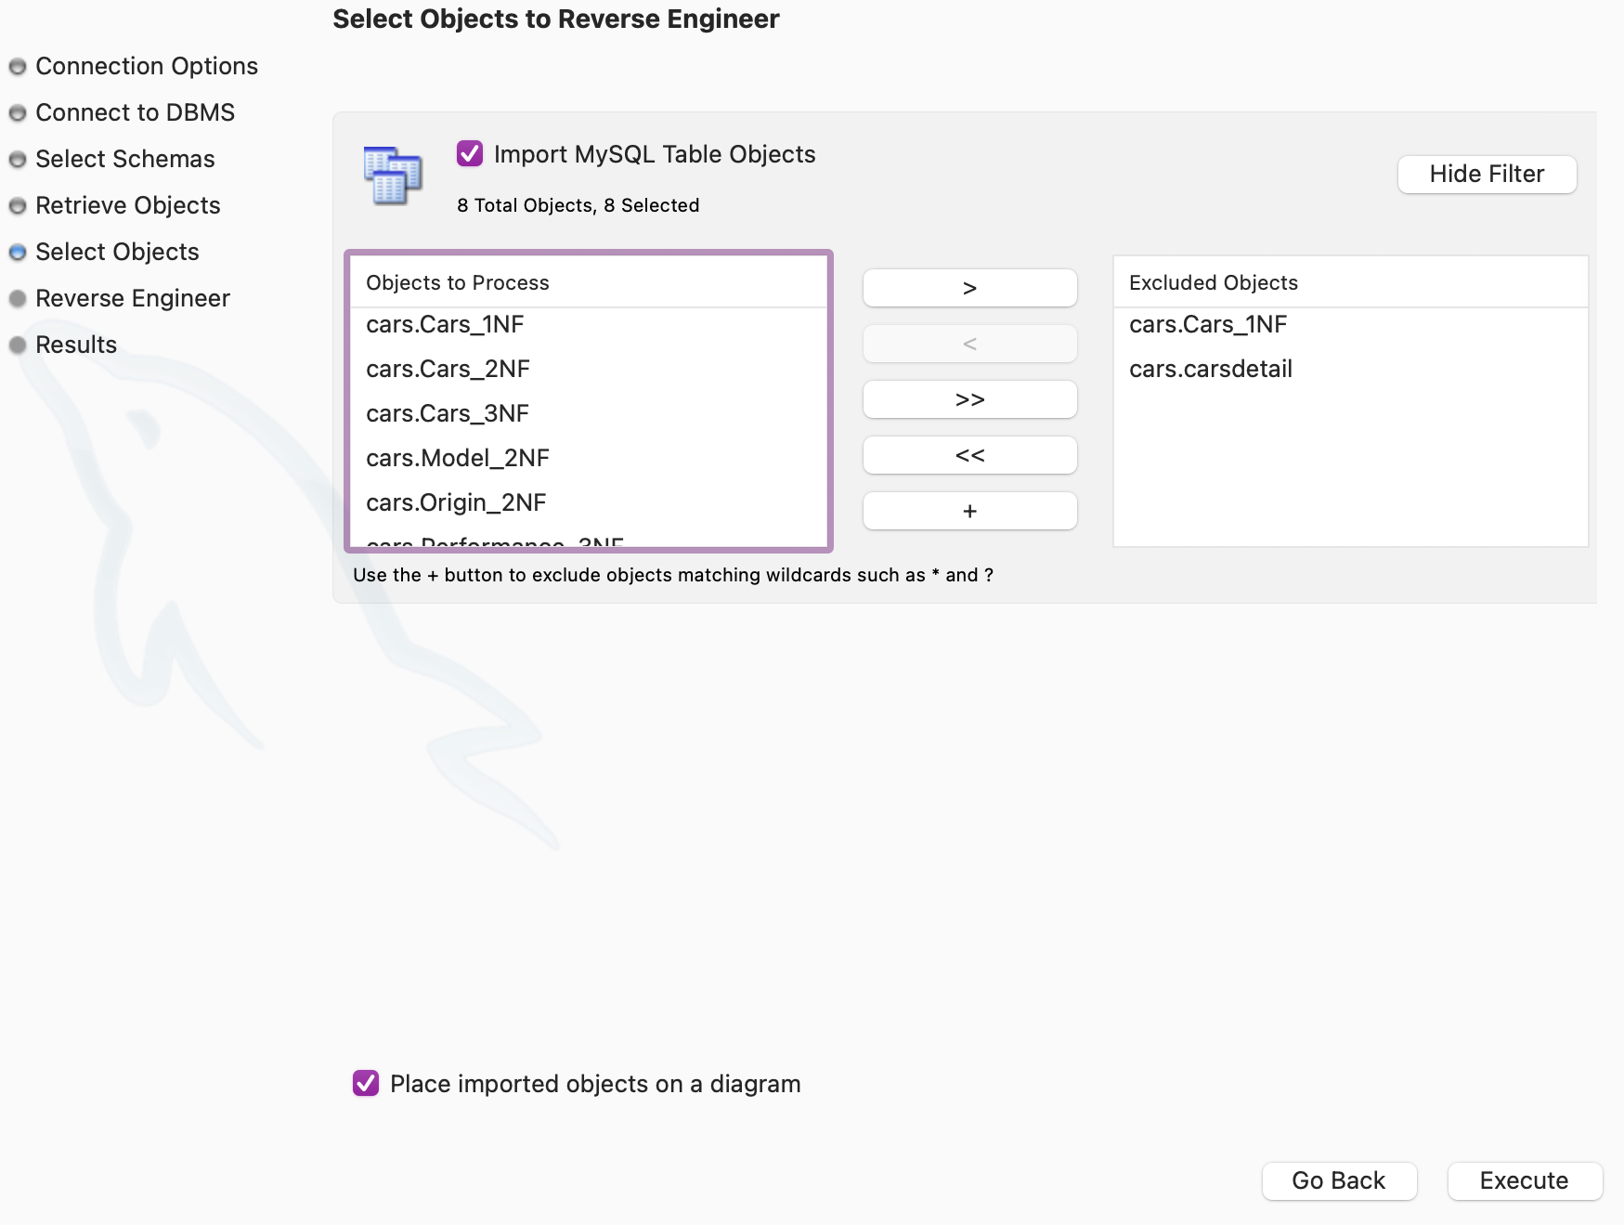

Step 7:

With the objects selected, the reverse engineering process was completed without any issues. All the required data from the schema was successfully retrieved, enabling me to review the results and ensure the diagram was accurate and complete.

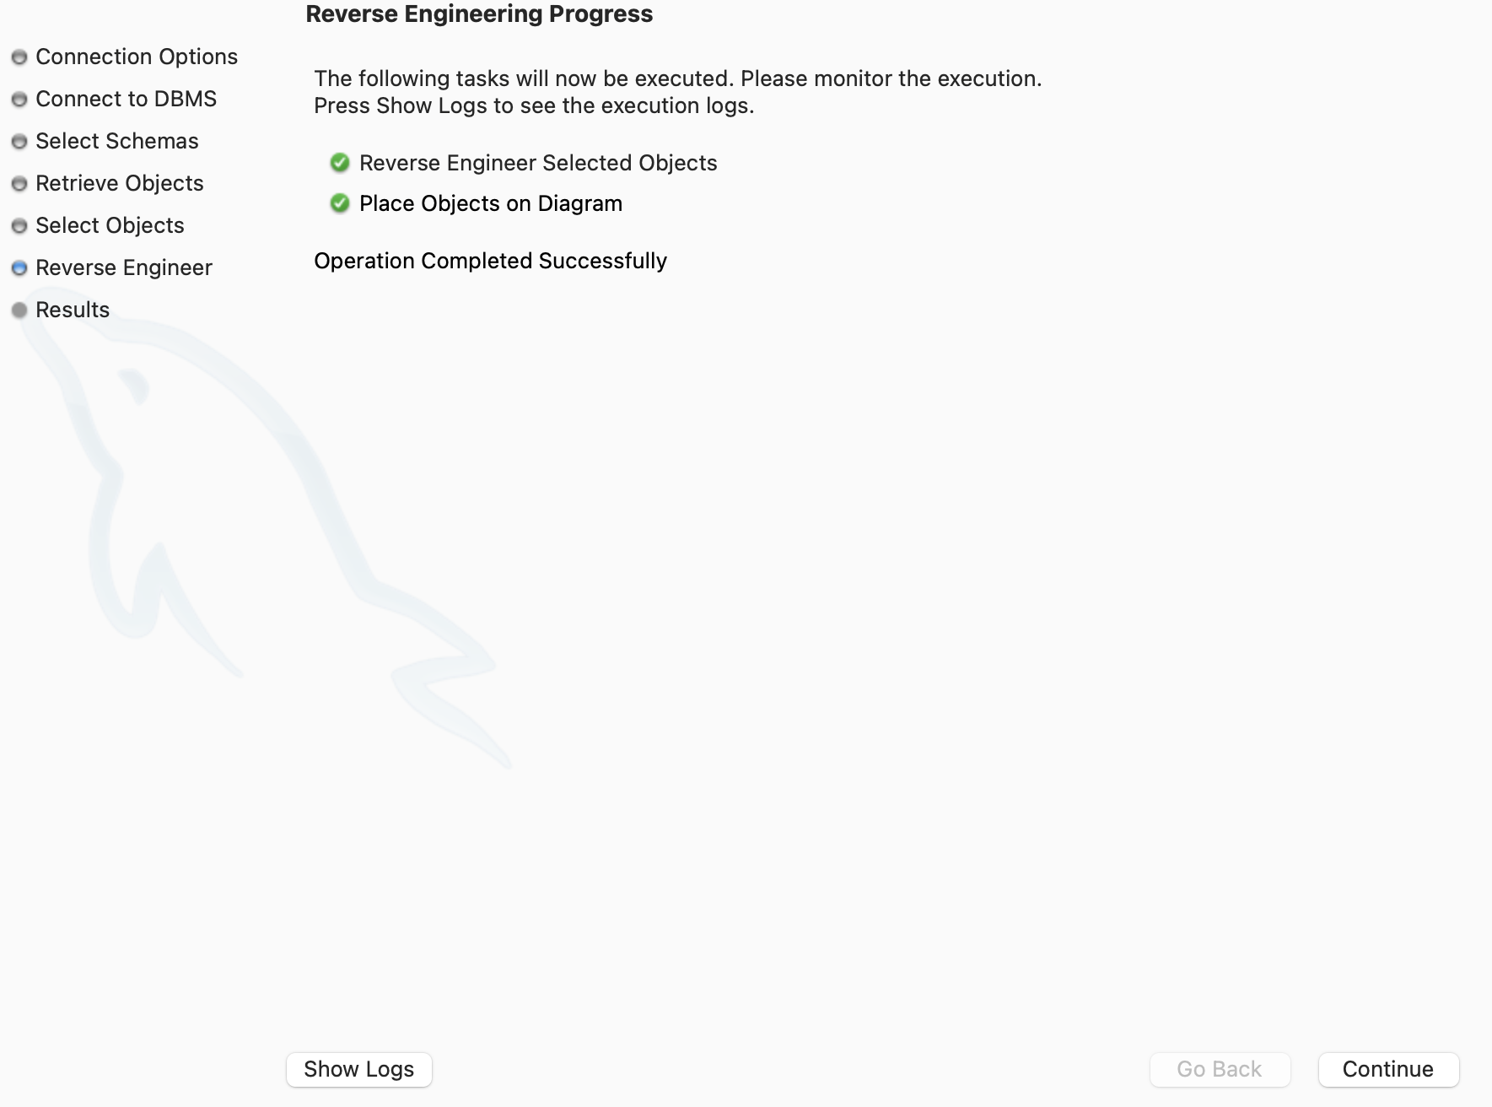

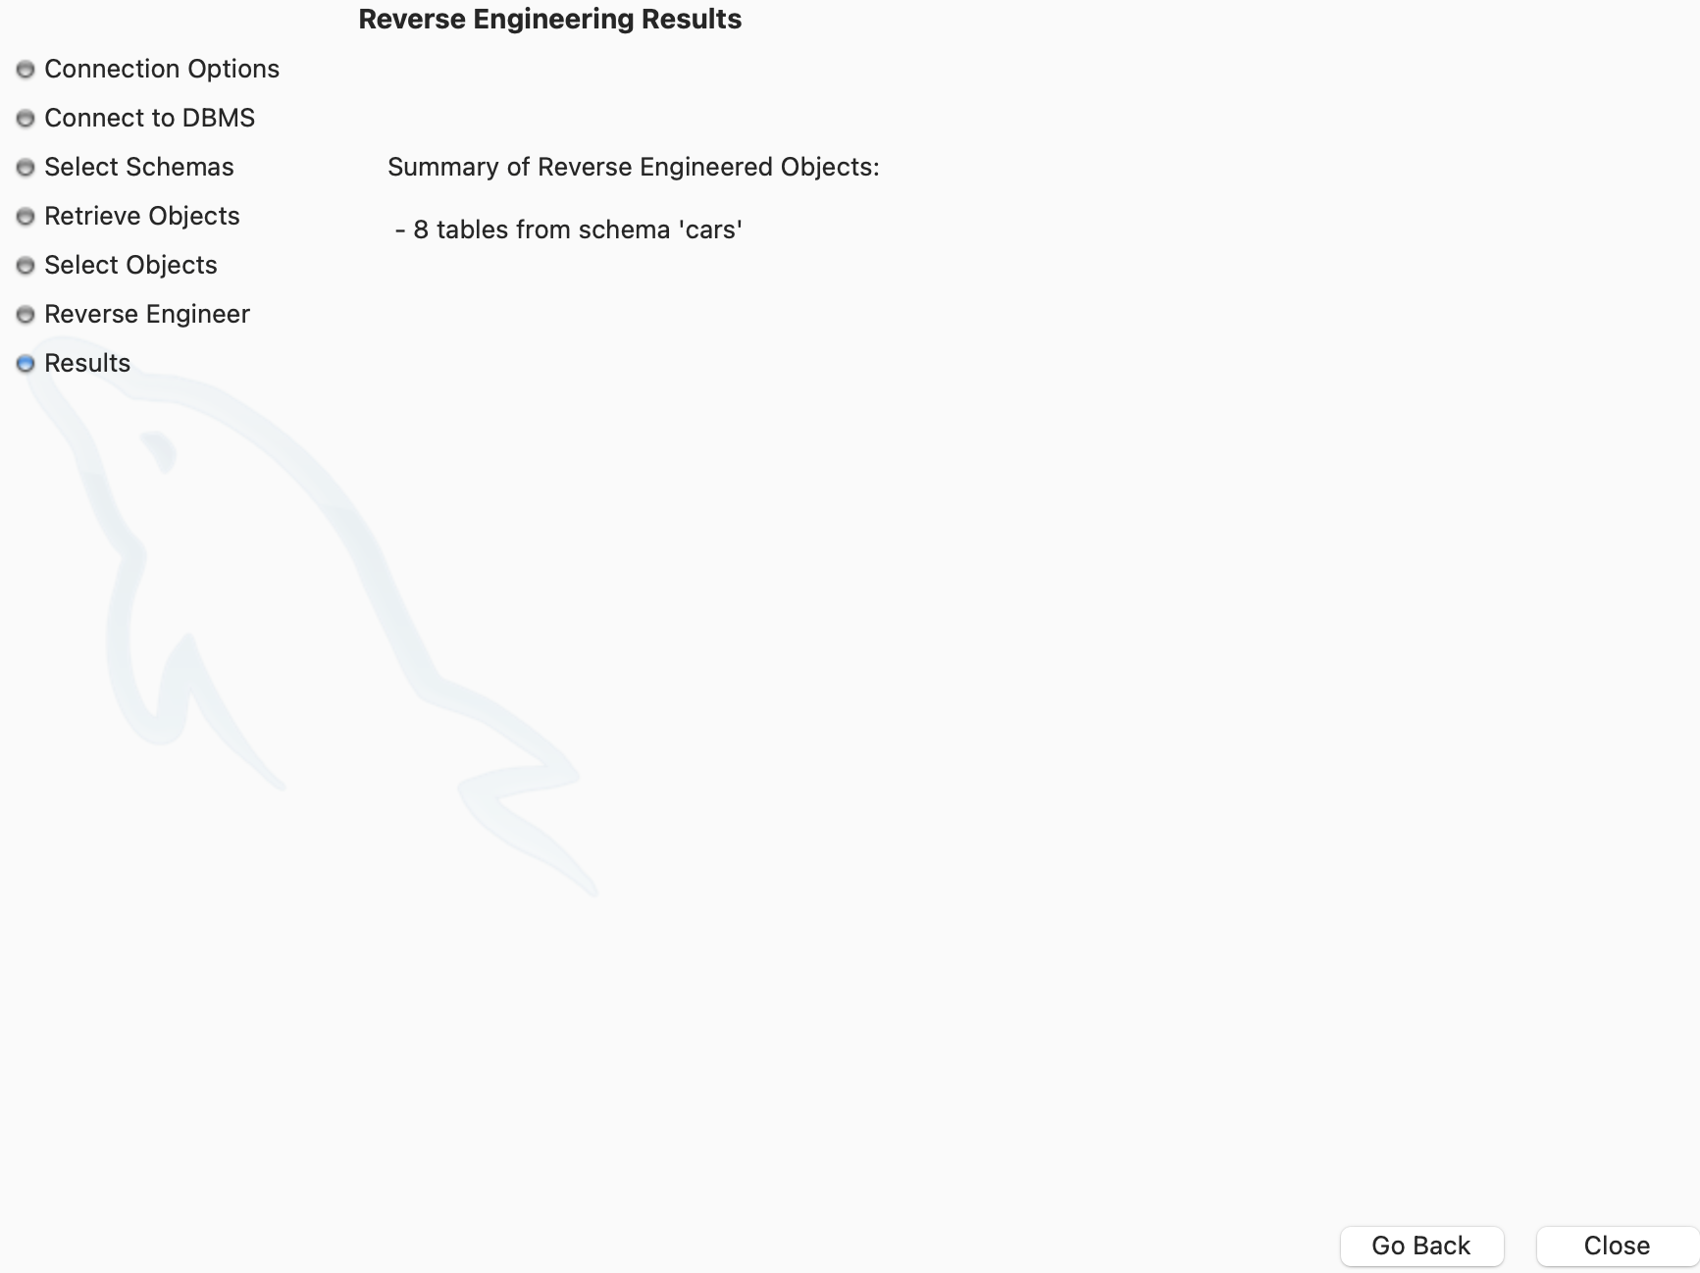

**Step 8:**

Finally, I removed any extraneous tables or objects that were unnecessary for the ERD. This cleanup streamlined the diagram, ensuring that the relationships among the entities in the cars dataset were clearly reflected. By adjusting and refining the visual representation, I was able to create an ERD that was more focused on the key elements of the database design.

**Step 9:**

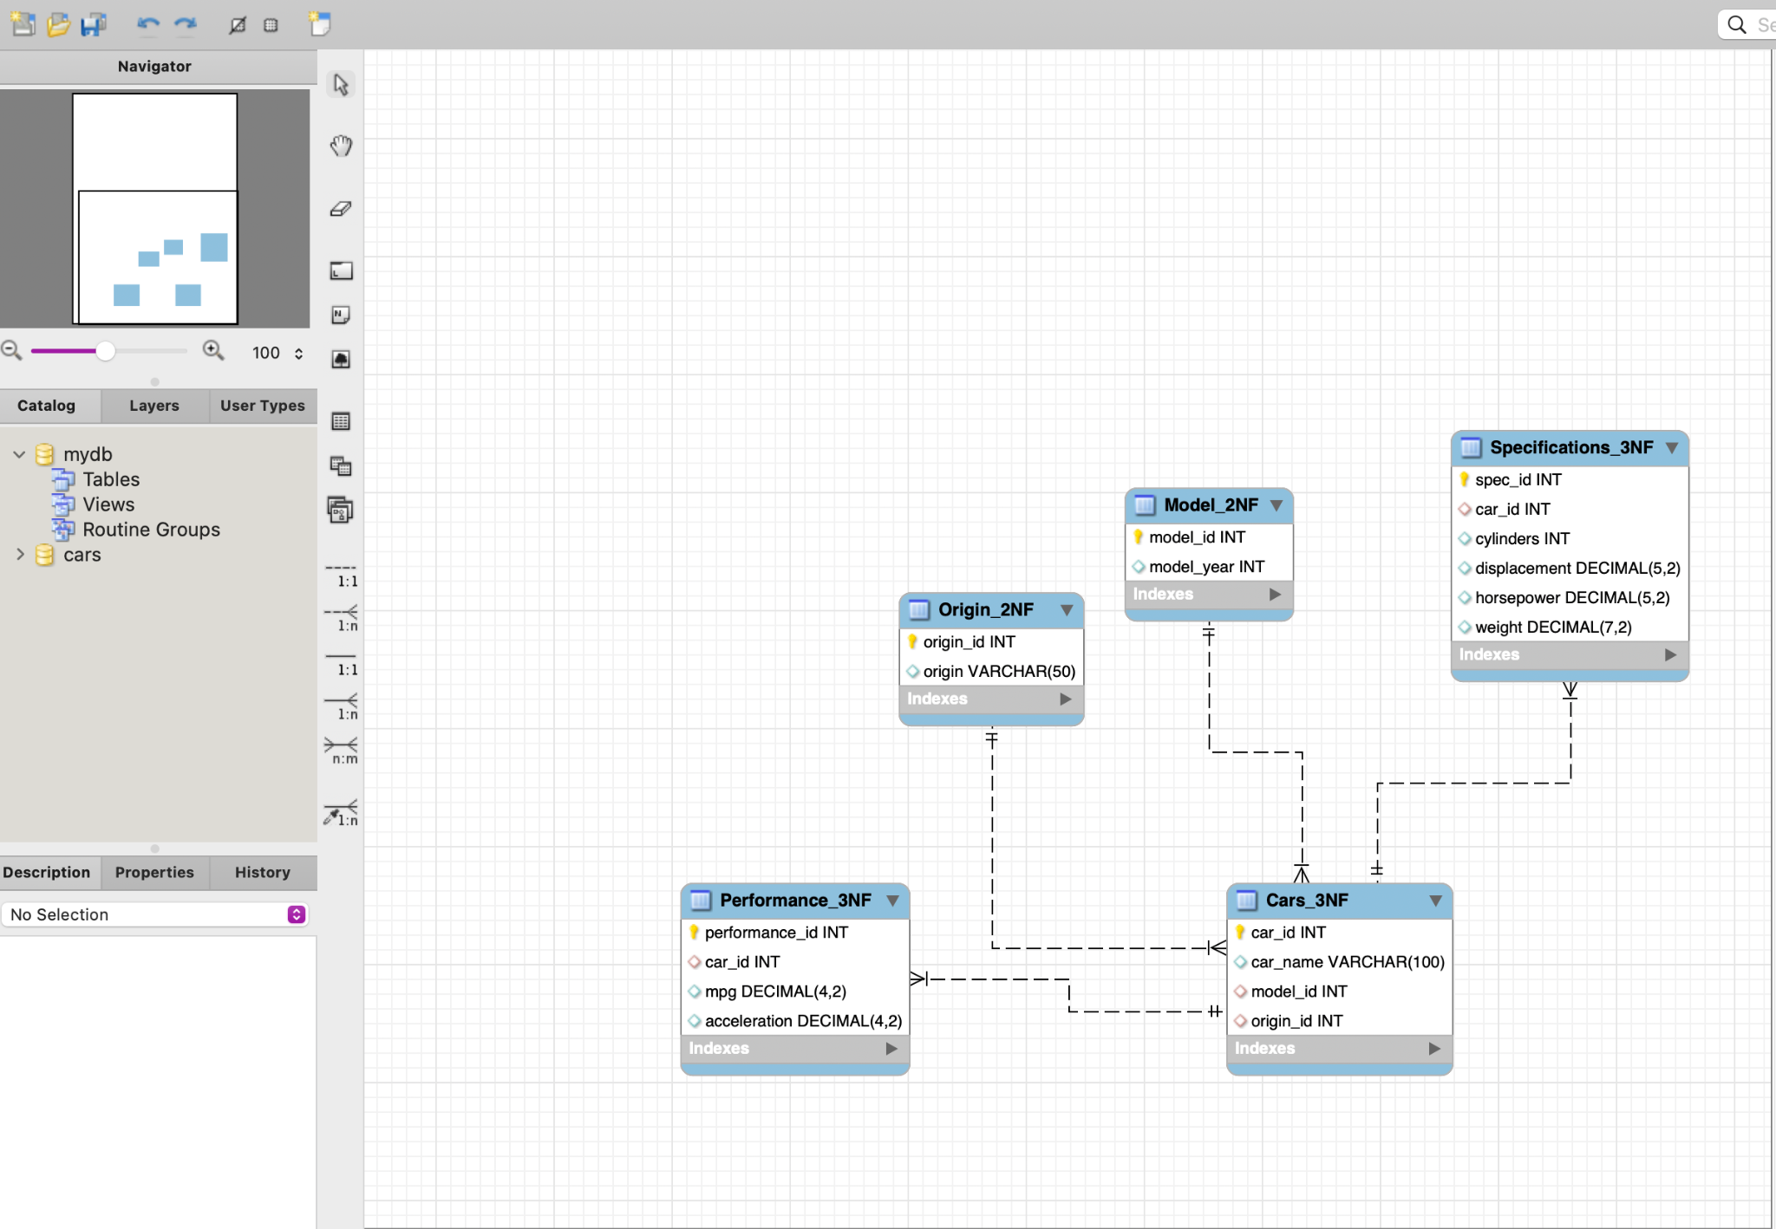

This Screenshot presents an Entity-Relationship Diagram (ERD) for a car-related database, with tables normalised to 2NF (Second Normal Form) and 3NF (Third Normal Form) to promote data integrity and minimise redundancy. Here’s an overview of the tables and their relationships:

Cars_3NF:

This table holds the primary details for each car, including the car_id (Primary Key) and car_name. It is linked to other tables through foreign keys such as model_id and origin_id, which connect to the Model_2NF and Origin_2NF tables, respectively.

Model_2NF:

This table stores information related to car models, with model_id serving as the primary key. The table includes model_year, representing the production year. A one-to-many relationship exists between Model_2NF and Cars_3NF, as a single model can correspond to multiple cars.

Origin_2NF:

This table captures the geographical origin of each car, with fields like origin_id (Primary Key) and origin(which stores the country or region as a VARCHAR field). The origin_id links this table to the Cars_3NF table.

Performance_3NF:

This table describes the performance characteristics of each car, such as mpg (miles per gallon) and acceleration. The performance_id is the primary key, and the table is connected to Cars_3NF through the car_id foreign key.

Specifications_3NF:

This table holds the technical specifications for each car, including attributes like cylinders, displacement, horsepower, and weight. The spec_id is the primary key, and car_id links this table to Cars_3NF, ensuring the correct specifications are associated with each car.

Relationships:

The dashed lines between the tables indicate one-to-many relationships:

- One model from Model_2NF can correspond to multiple cars in Cars_3NF.

- One origin from Origin_2NF can be associated with many cars in Cars_3NF.

The car_id foreign key serves as the link between Cars_3NF, Performance_3NF, and Specifications_3NF, ensuring that each car’s performance and specifications are properly recorded and linked.

Part 2:

**Query 1: List All Cars with Their Specifications and Performance.**

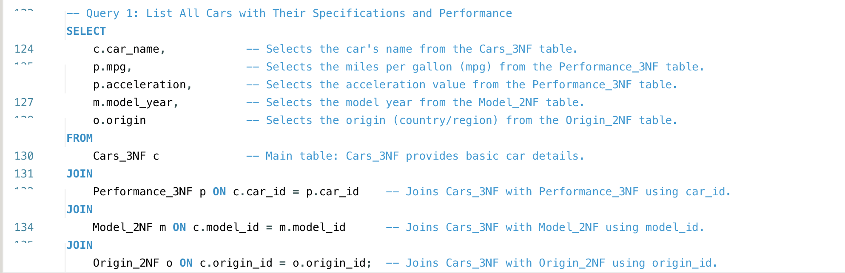

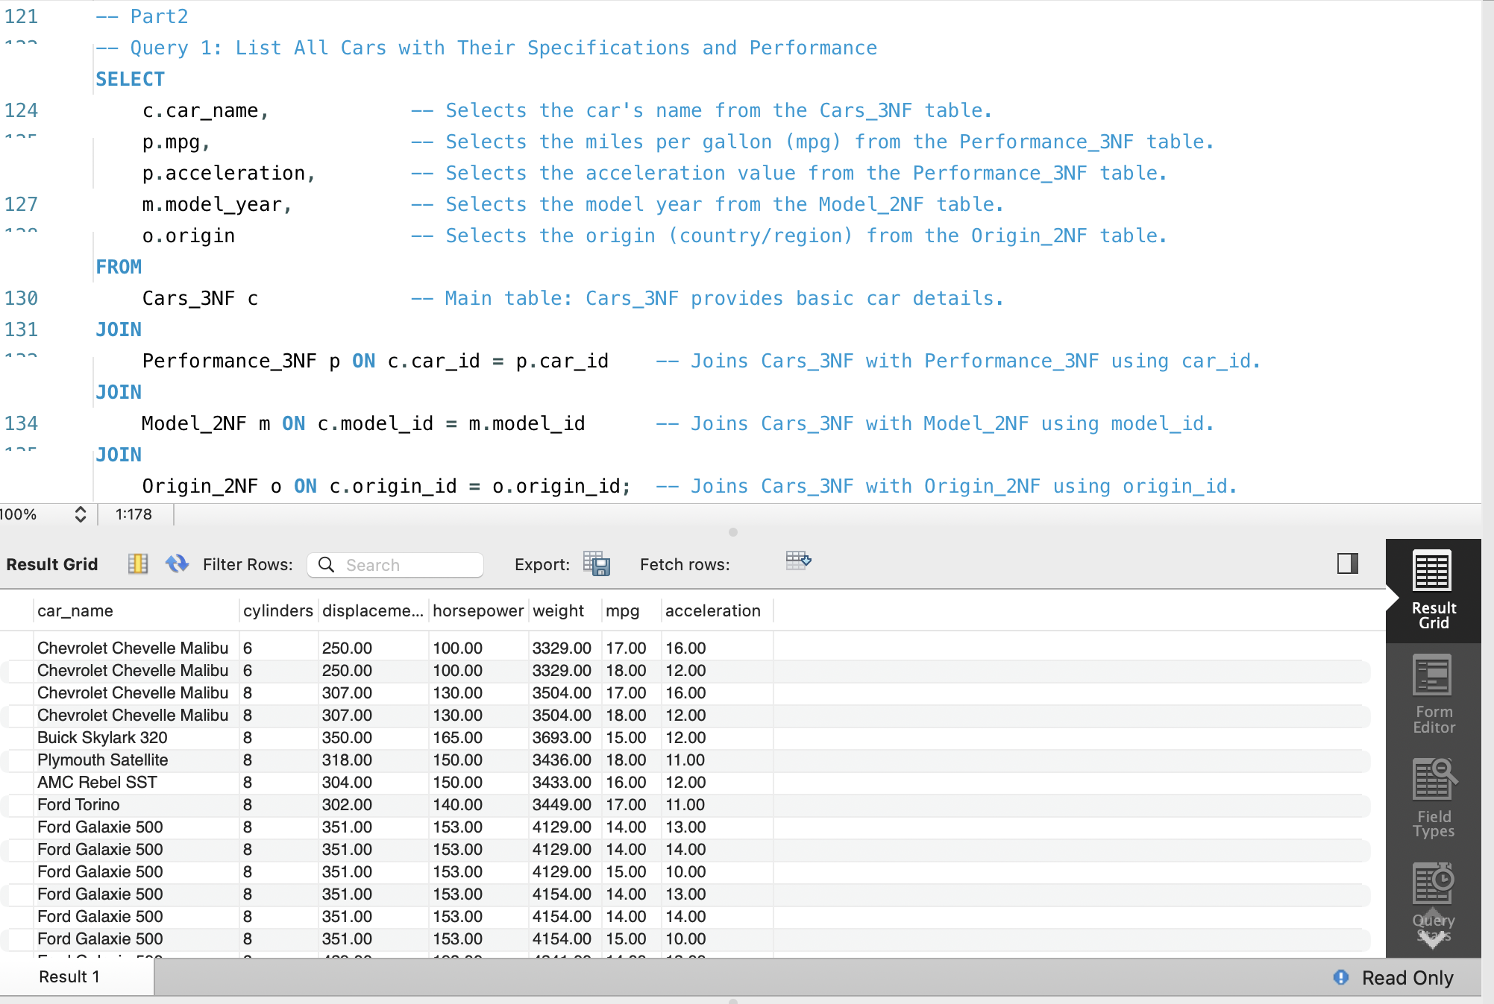

Explanation:

This query retrieves a list of cars along with their specifications (such as cylinders, displacement, horsepower, and weight) and performance metrics (mpg and acceleration). The JOIN statements connect the Cars_3NF table to the Specifications_3NF and Performance_3NF tables via the car_id field, ensuring that the correct specifications and performance data are matched to each car.

**Query 2: Display performance data (name, mpg, acceleration, model year, origin)**

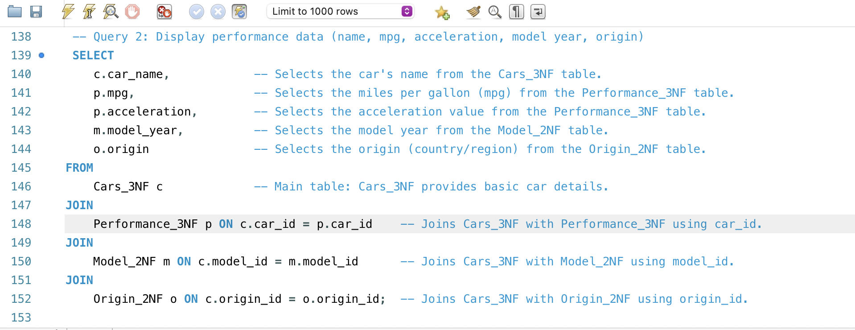

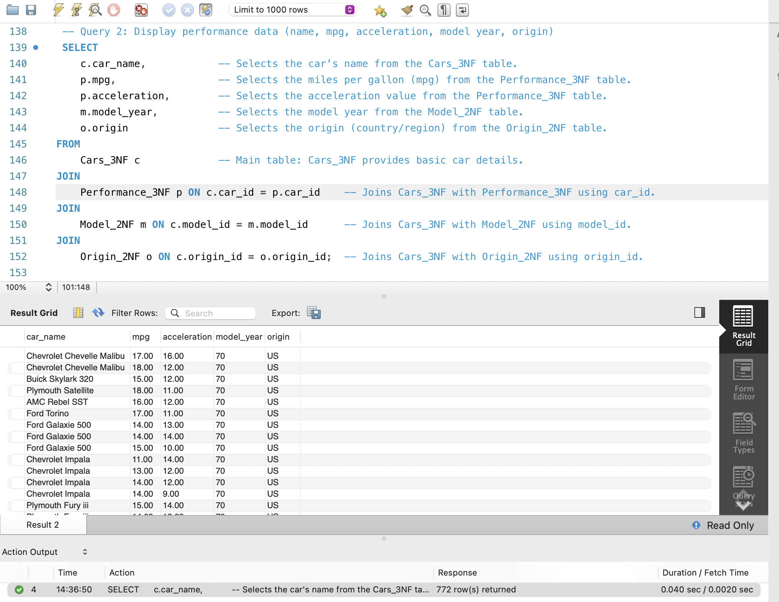

This query displays the performance data for each car, such as the car's name, miles per gallon (mpg), acceleration, model year, and country or region of origin. It uses three JOIN statements to link the Cars_3NF table to the Performance_3NF, Model_2NF, and Origin_2NF tables, allowing you to pull in data from each respective table.

Query 3: Find cars with the highest horsepower by model year and origin

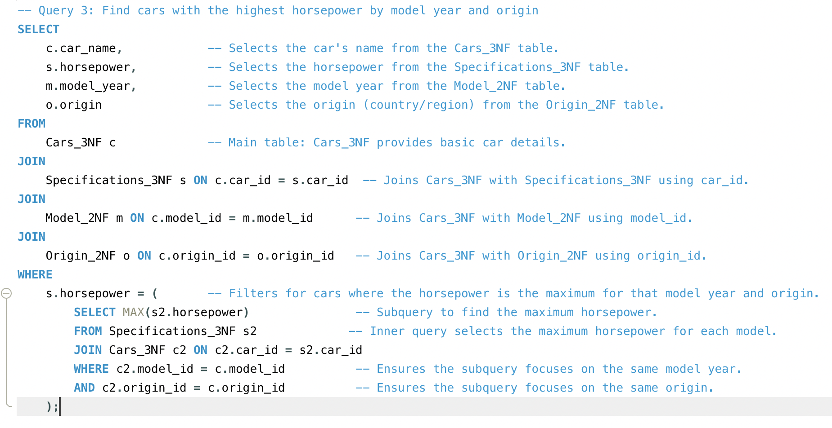

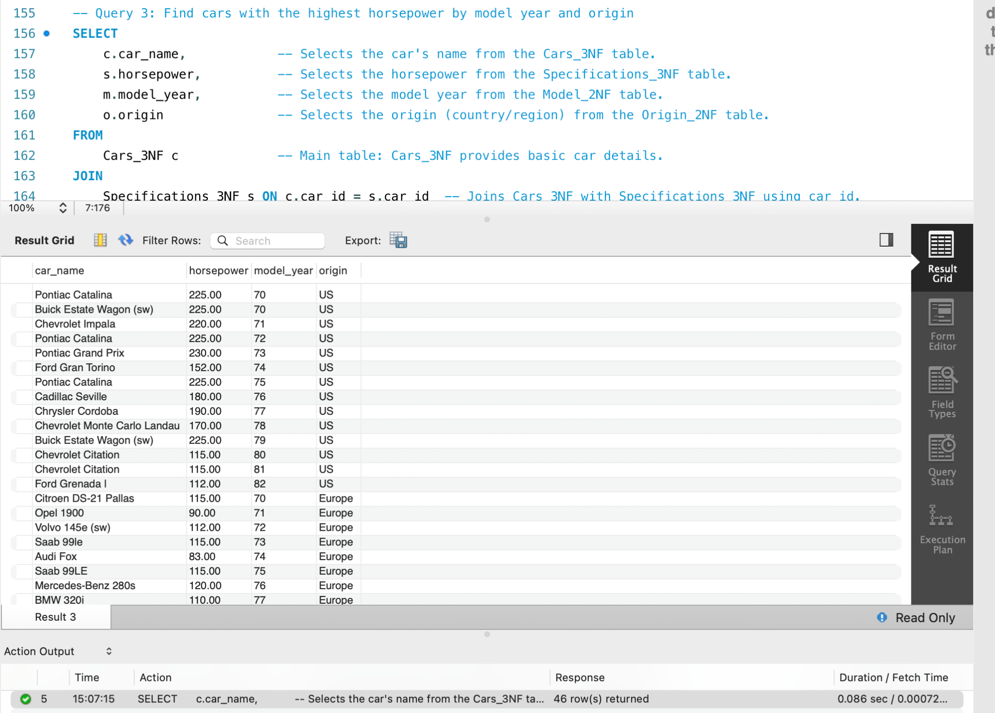

Explanation:

This query returns the cars with the highest horsepower for each model year and origin. It first joins the Cars_3NF table with the Specifications_3NF, Model_2NF, and Origin_2NF tables. Then, it uses a subquery to find the car with the highest horsepower by comparing each car's horsepower to the maximum horsepower for that particular model year and origin. The subquery filters out other cars that do not match the maximum horsepower.

**Conclusions**

In this project, my main objectives were to create a well-organised database for the cars dataset, ensure it followed normalisation principles, and develop a clear entity-relationship diagram (ERD) to illustrate the connections between different tables. I'm happy to report that I achieved these goals. The database was divided into separate tables, with all attributes adhering to normalisation rules, and functional dependencies were clearly established. The ERD successfully depicted the relationships among the entities, serving as a useful reference for understanding the database's structure.

**Pros and Cons of Tools, Methods, and Techniques**

**Pros:**

MySQL Workbench: This tool was intuitive and offered strong features for both designing databases and reverse engineering them. Its ability to visually represent data made it easy to create and adjust the ERD, while the reverse engineering function simplified the process of extracting schema information from the database.

Normalisation: Implementing normalisation techniques (1NF, 2NF, and 3NF) helped reduce data redundancy and maintain data integrity. This resulted in a more efficient database structure that is easier to manage and query.

Structured Approach: Following a systematic method for database design and normalisation led to a clear organisation of data, making it simpler to manage and update.

**Cons:**

Learning Curve: Although MySQL Workbench is powerful, it can be challenging for those new to database management systems, which might slow down initial progress.

Time-Consuming: The normalisation process is essential but can be lengthy, particularly when ensuring that all functional dependencies are accurately identified and implemented.

**What I Would Do Differently**

If I were to tackle this project again, I would:

Conduct a Detailed Requirements Analysis: Before diving into the design phase, I would gather more comprehensive requirements to ensure the database structure aligns closely with the intended use cases. This could involve working closely with potential users to understand their needs and expectations better.

Explore Alternative Tools: While MySQL Workbench was effective, I would consider looking into other database design tools that might offer additional features or a more user-friendly interface, potentially saving time on design and implementation.

Incorporate Advanced Techniques: I would investigate using more advanced normalisation techniques or data modelling strategies to further optimise the database structure and improve performance.

Overall, this project was a valuable learning experience, and I met my initial expectations. By utilising effective tools and methods, I was able to develop a robust database design that efficiently meets the needs of the cars dataset.

**References:**

W3Schools. (n.d.). SQL INSERT INTO SELECT statement. W3Schools. Retrieved October 2, 2024, from <https://www.w3schools.com/sql/sql_insert_into_select.asp>